Peterloo Activity: Tell the story of Peterloo

Task 1

These cartoons tell the story of the events of 16 August 1819, but they have been mixed up. Rearrange the cartoons into the correct order and put the right caption with each.

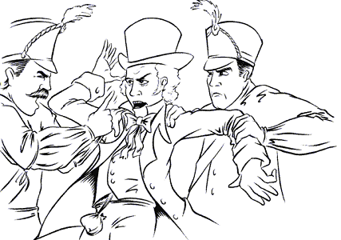 | 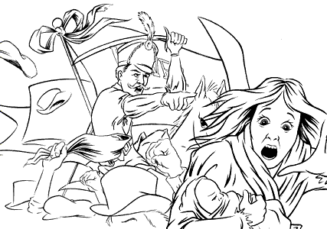
The cavalry wave their sabres and people flee in all directions. | Suddenly, yeomen rush through the crowd to arrest Hunt and the other speakers.
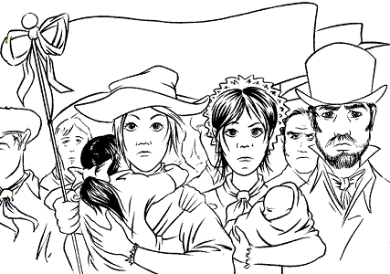 | 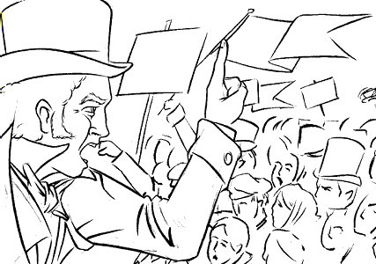
People hold banners demanding “Annual Parliaments” and “Vote by Ballot”.  Cut along the dotted lines  | A crowd gathers at St Peter’s Field to hear Henry Hunt, the radical reformer.

Peterloo
Task 2

Write an article for a newspaper describing the events at St. Peter's Field. Use information contained in all the sources in this gallery. Choose to write your article supporting one of these three points of view:
- Take the side of the magistrates
- Take the side of Henry Hunt
- Give a balanced account of what happened.

Task 3

In pairs, discuss the following questions:
- How did the government try to restrict the political rights of the people demonstrating at Peterloo? Write a list.
- Why did the government fear the demand for political rights and reform at this time?

