Chartists

Activity: The People's Charter

The People’s Charter had six main aims. They are listed here in this document.

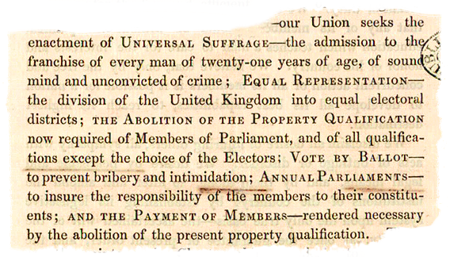
(Catalogue ref: HO 45/2410A, 1848 handbook of the People’s Charter Union)

Make a poster about one of the points from the People's Charter by completing the paragraphs that have been started for you.

- Choose a point that you think was important.
- Explain why you think this point is important in your poster.

We demand that ...

This is important because ...

