



1a Why did the Overseers make this report?
1b What did the Overseers find was wrong with the Workhouse?
1c Why do you think conditions like this existed?

This is the report of the Overseers of Huddersfield in May 1847, after they received a letter from Thomas Tatham, the Medical Officer for the northern district of Huddersfield.
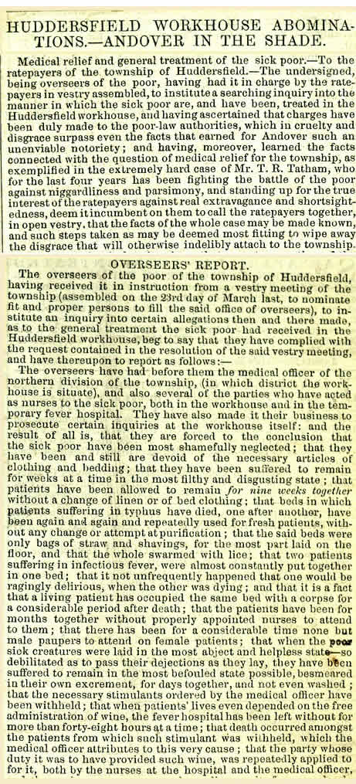
(PRO ref: MH12/15070)

