



2a Why did Thomas Tatham write the letter?

2b List all the things that he claimed were wrong with the Huddersfield Workhouse?

2c Was Thomas Tatham qualified to make comments on the workhouse?

Look back at source 1

2d Is Thomas Tatham complaining about the same things that were mentioned in the Overseers' Report?

2e Had the conditions in the workhouse improved after the Overseers' Report in May 1847?
Look back at source 1

This is another letter, which was sent in June 1847 by Thomas Tatham to the Chairman of the Board of Guardians in Huddersfield. Thomas Tatham was the Medical Officer for the north of Huddersfield who had already complained about the workhouse a number of times.
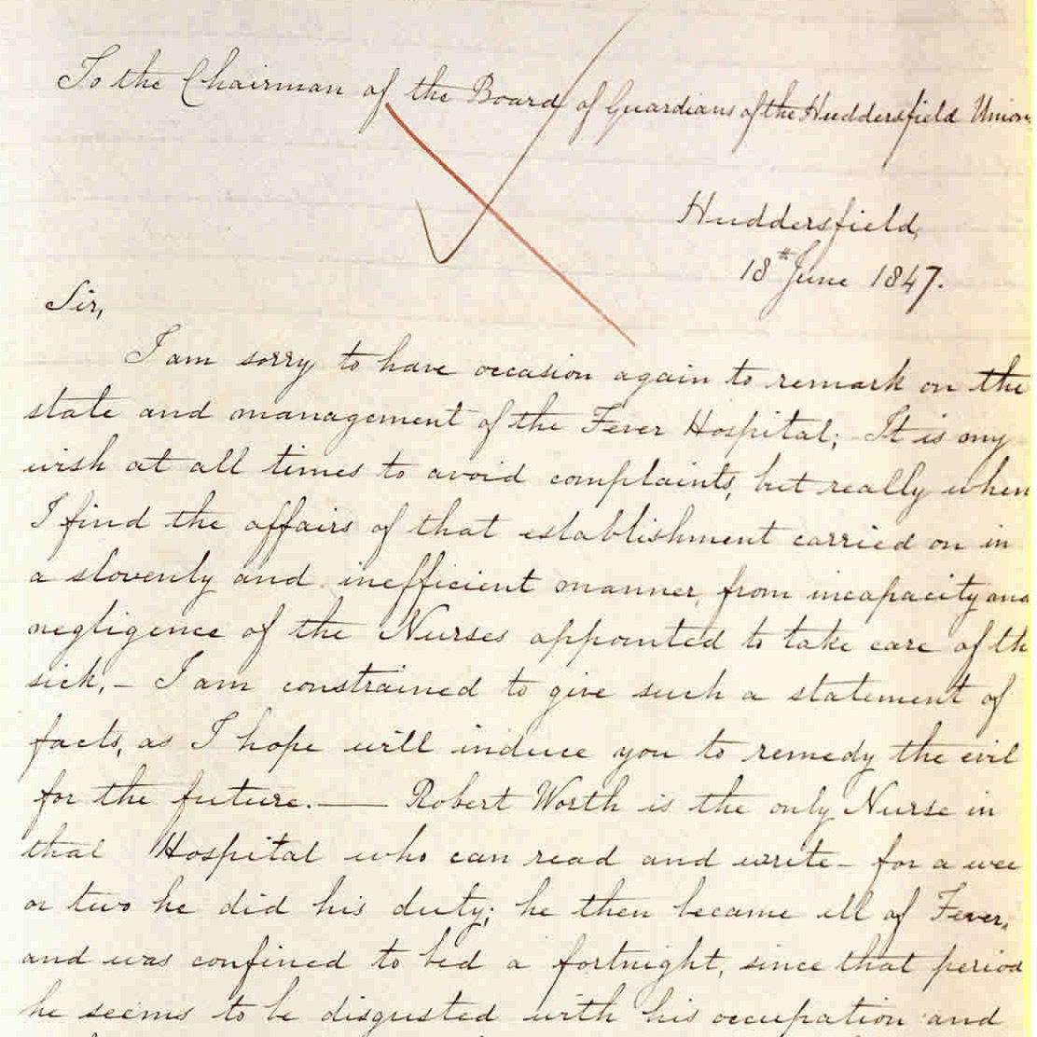

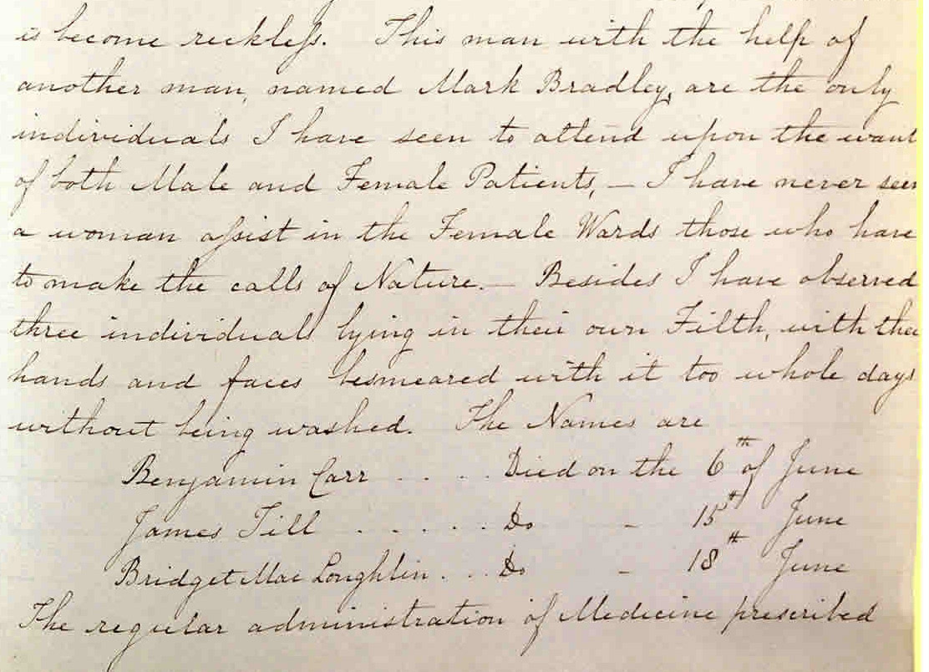

(PRO ref: MH 12/15070)

