


3a How many inmates were in the workhouse?
3b Choose one day and work out what food was consumed in the workhouse?
3c Were the inmates of the workhouse getting a healthy diet? What was wrong with the diet?
Are there any signs that the matron realised that the diet was not good enough?
Look back at sources 1 and 2 and think about what you have learnt from source 3.
3d Do these sources suggest that the Overseers had made a serious attempt to reform the workhouse after Thomas Tatham's letters?
3e If you were in charge of the workhouse, what changes would you make to improve the conditions? Source 4

This is the dietary for the Huddersfield Workhouse. This was the list of meals that were supplied to the inmates of the workhouse.

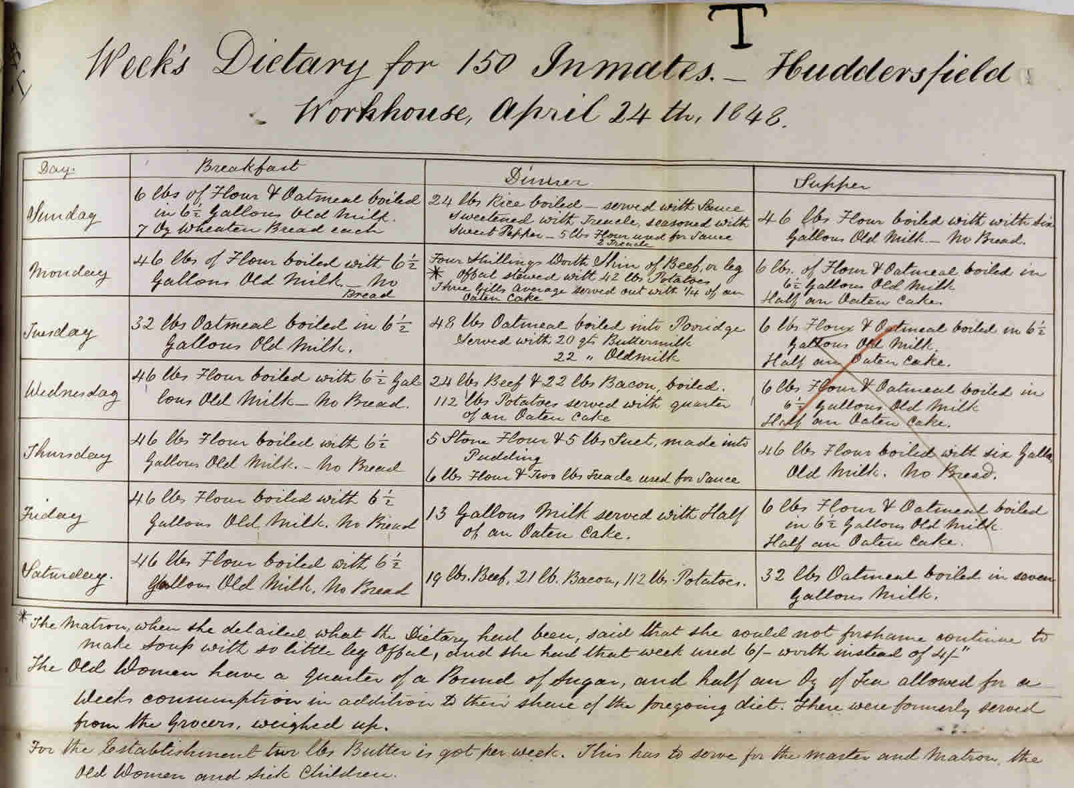

(PRO ref: MH12/15070)

