



4a In what ways are the complaints the same as those made in:
i) the letter from Thomas Tatham
ii) the first report
iii) the dietary?
4b Look back at the first four sources, and write an account of what happened in the Huddersfield workhouse from 1847-8.

This is part of a second report made by the Overseers of the Workhouse in June 1848.

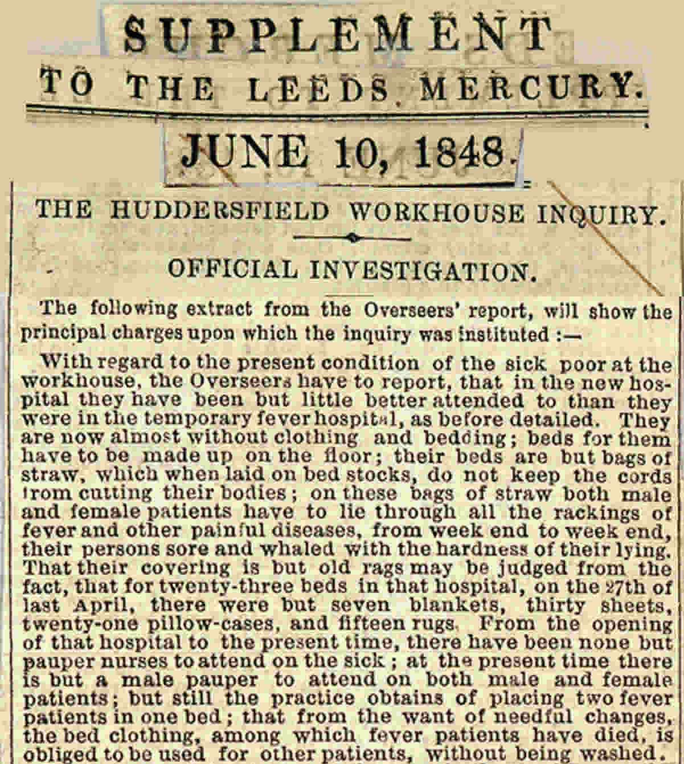

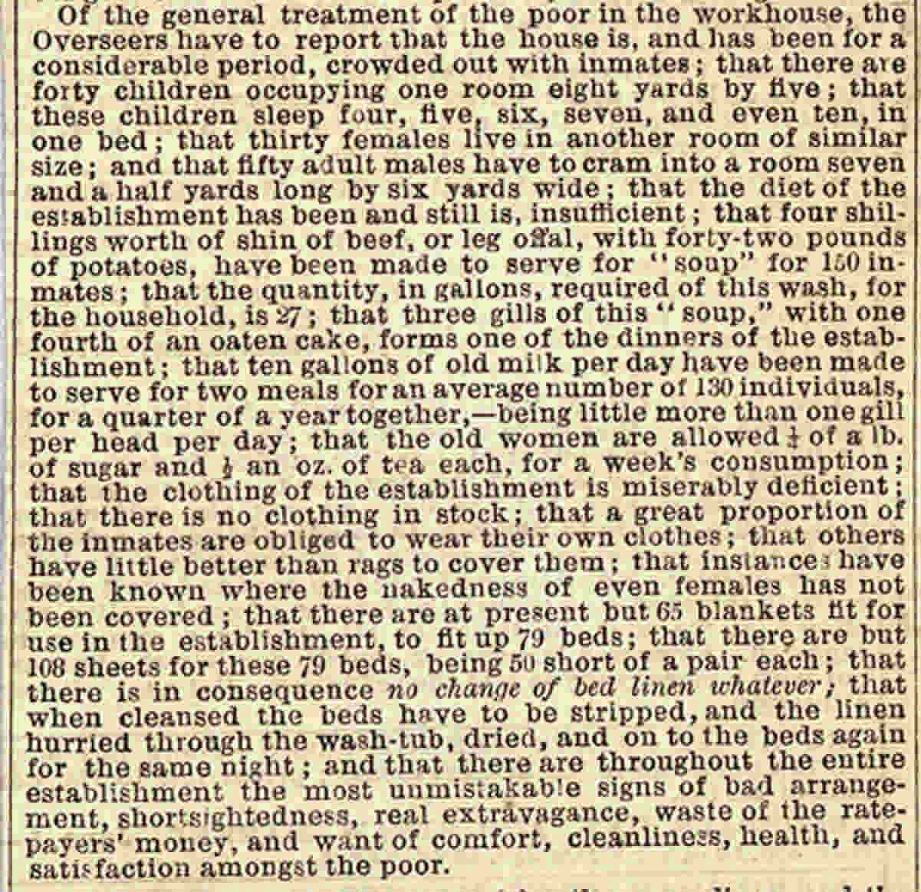

(PRO ref:MH 12/15070)

