



Look back at source 3
5a In what ways is this dietary different from Huddersfield's?
5b What evidence is there that some people received special treatment?
5c Which dietary is better, Reigate or Huddersfield? List five reasons why you have made your choice.

This is the dietary for the Reigate Workhouse in Surrey.
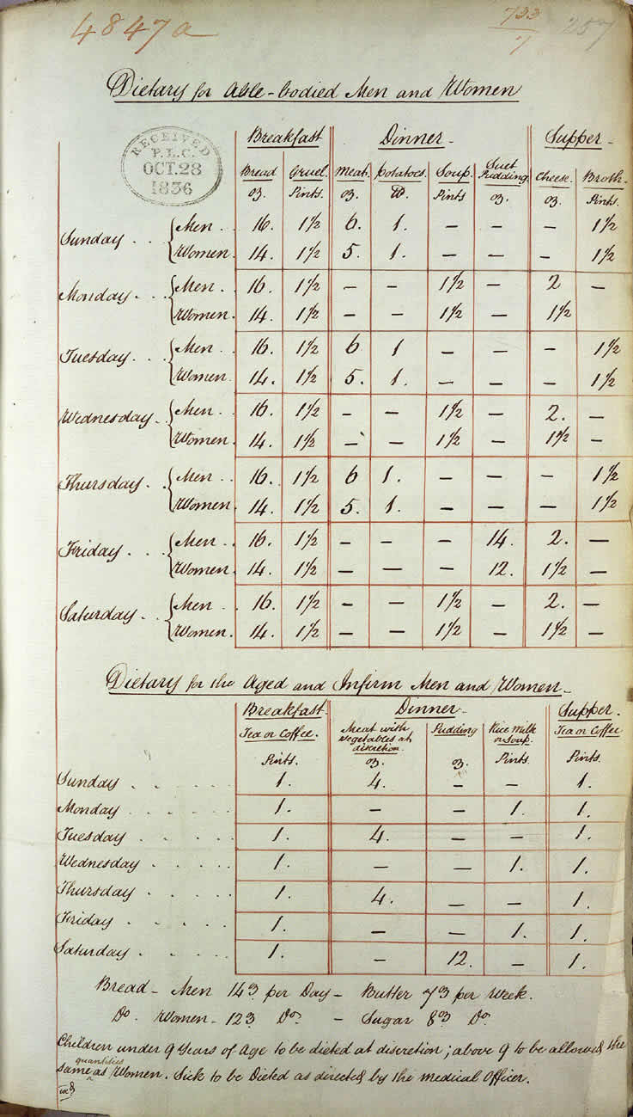

(PRO ref: MH 12/12575)

