



6a Write down the names of the people on the list and how much relief they had been allowed by the Board of Guardians.
6b How does the Board explain each payment?
6c Why do you think the Assistant Commissioner wanted the payments explained?

This is part of a letter sent from the Reigate Union to an Assistant Poor Law Commissioner. His job was to inspect the Unions in his area and make sure that they were obeying the rules laid down by the 1834 Act.
The letter explains why the Union paid outdoor relief to people living outside the workhouse which was not encouraged. Wages are given in pounds and shillings.
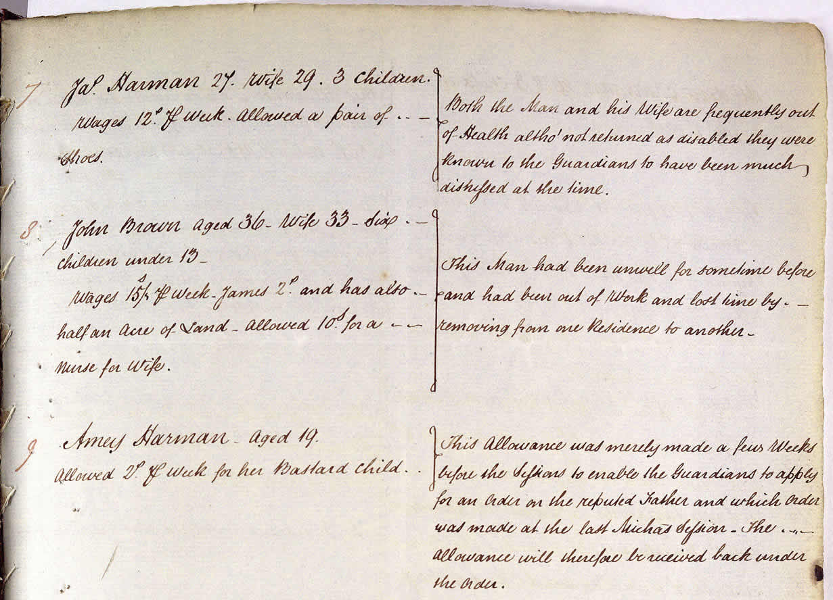
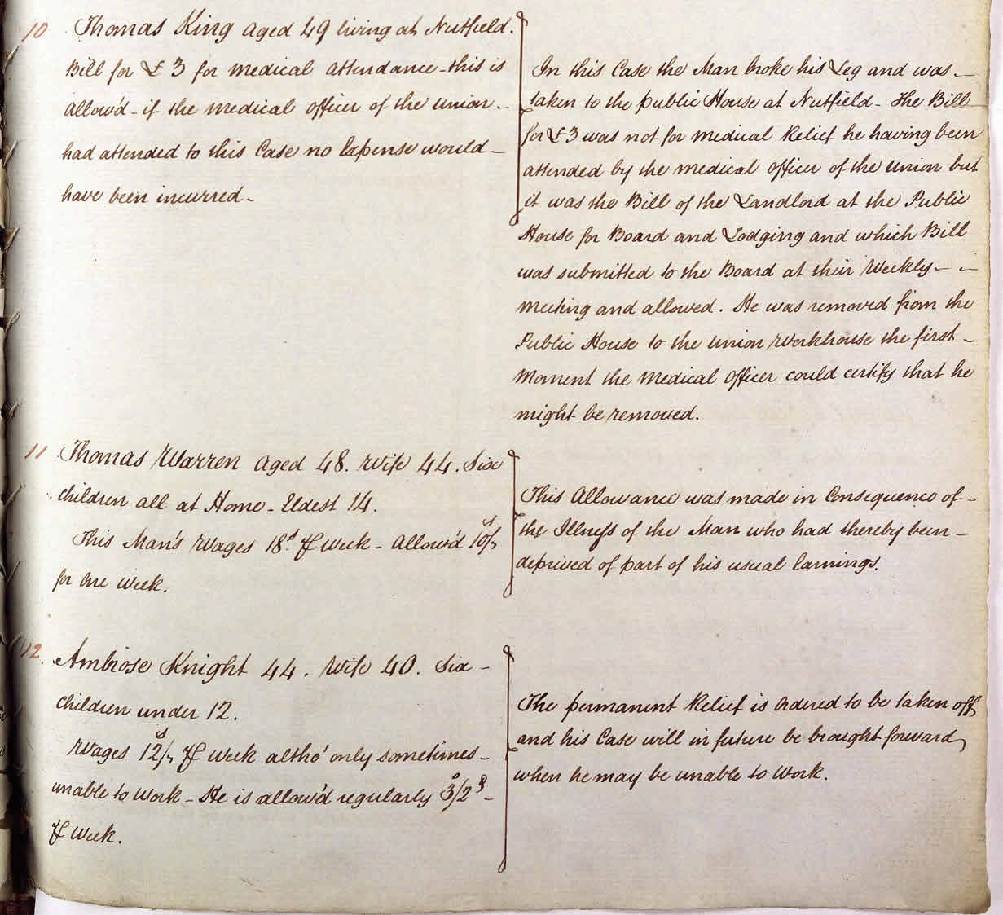
(PRO ref: MH 12/12575)

