

This is an extract from a report by the Assistant Poor Law Commissioner
on the Reigate Workhouse on 12th February 1851. (PRO ref: MH 12/12577)

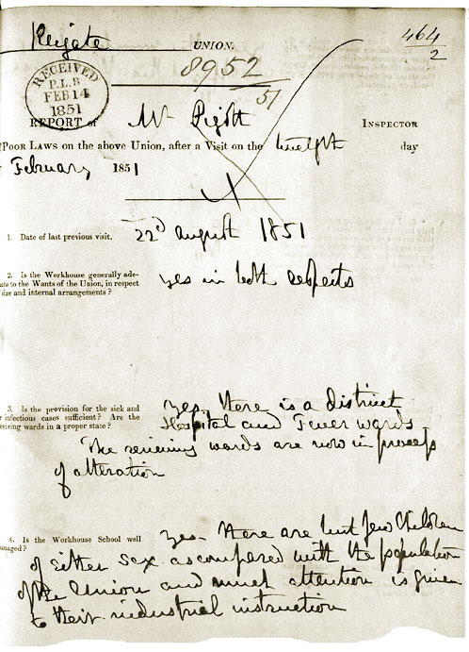 (PRO ref: MH 12/12577)
