



8a. What recommendations did the Assistant Commissioner make?
8b. What evidence is there that he was concerned about the ways that children were being treated?
Look back at Source 7, which was written by the same man who wrote Source 8.

8c The Poor law Commissioners were sometimes accused of only being concerned with saving money. Do these sources suggest that this was the case?

This is part of a letter written by an Assistant Poor Law Commissioner
to the Poor Law Commissioners.

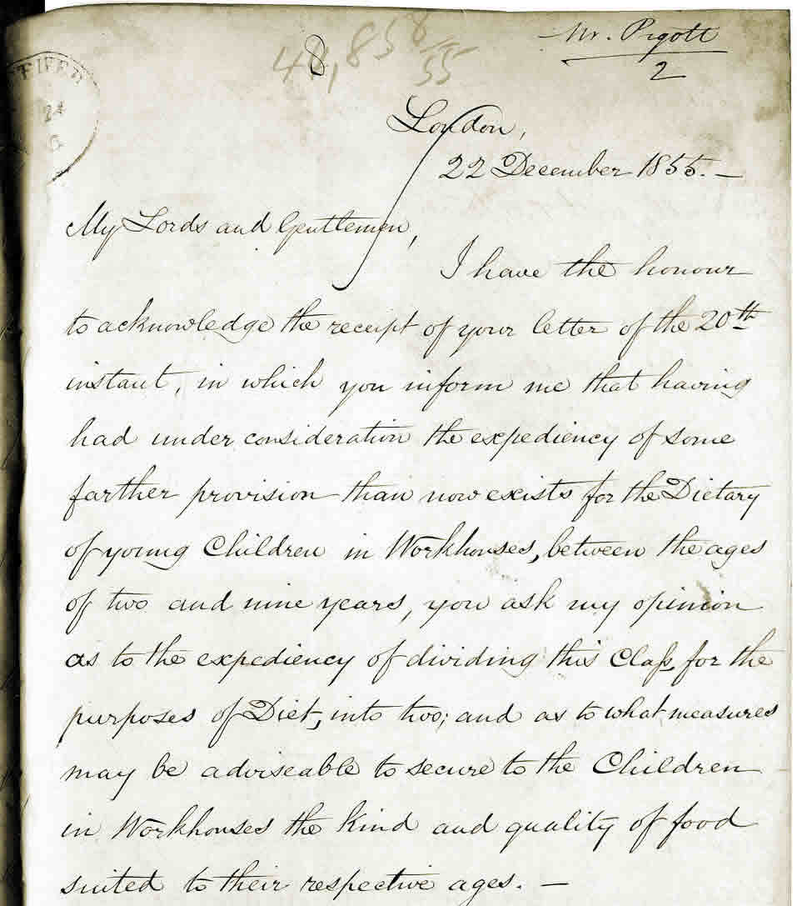

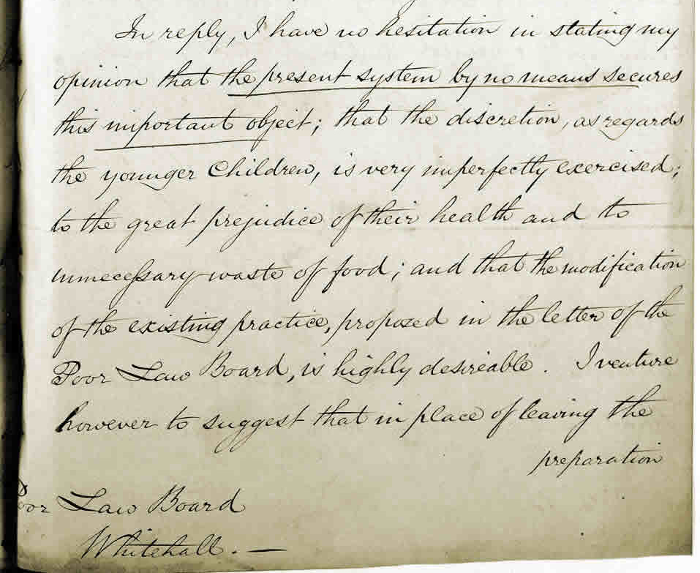

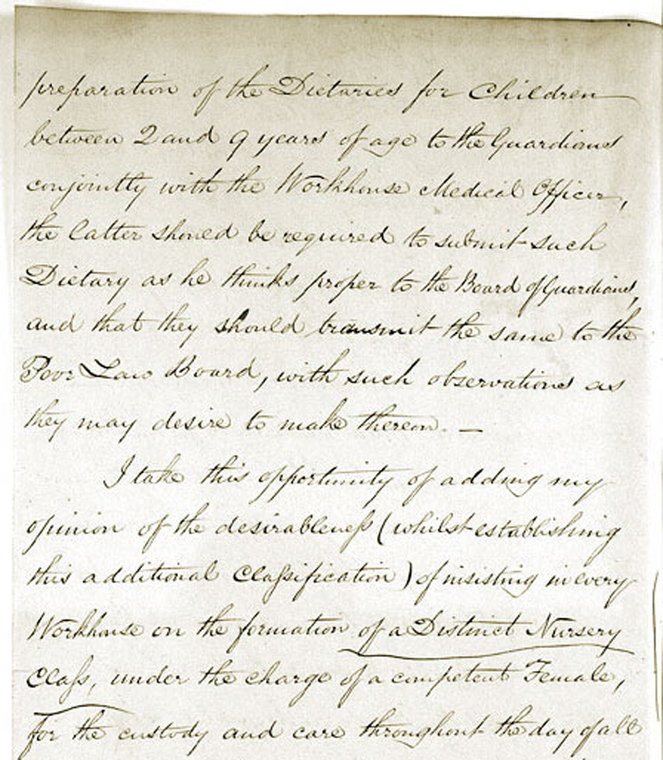

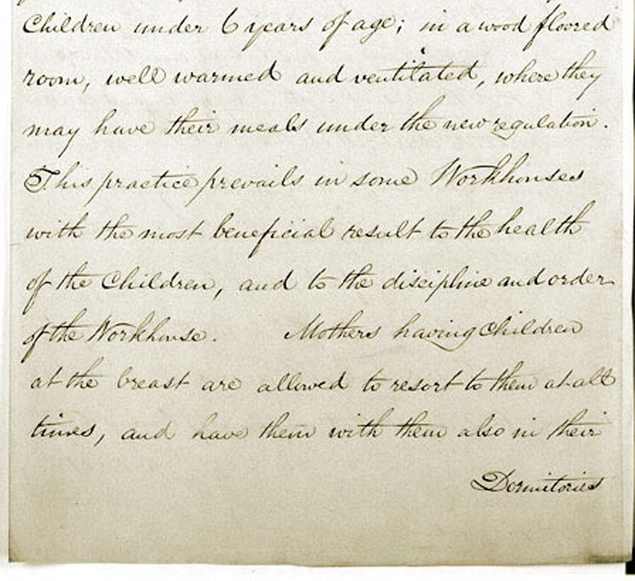

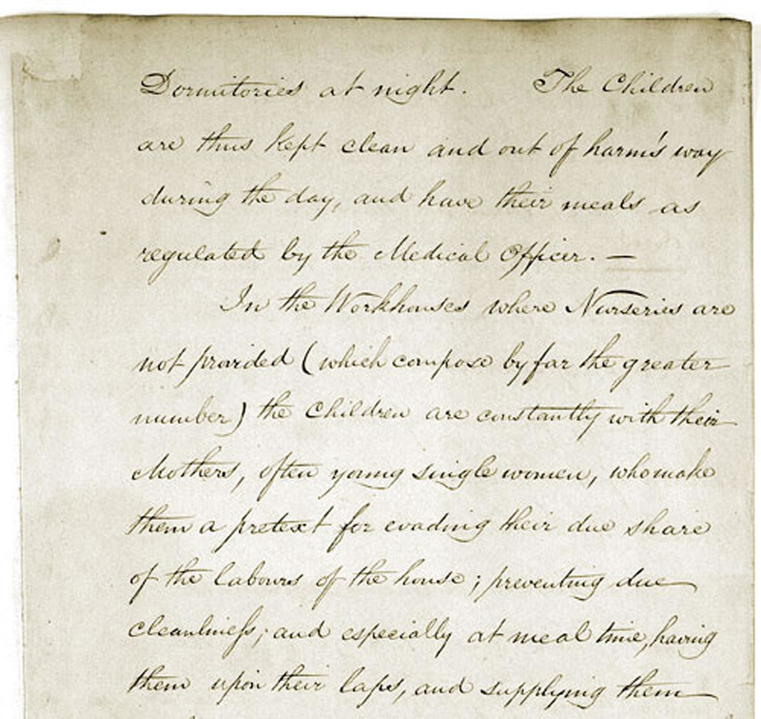

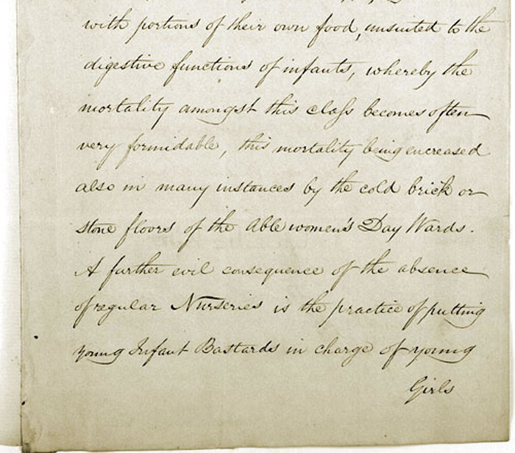

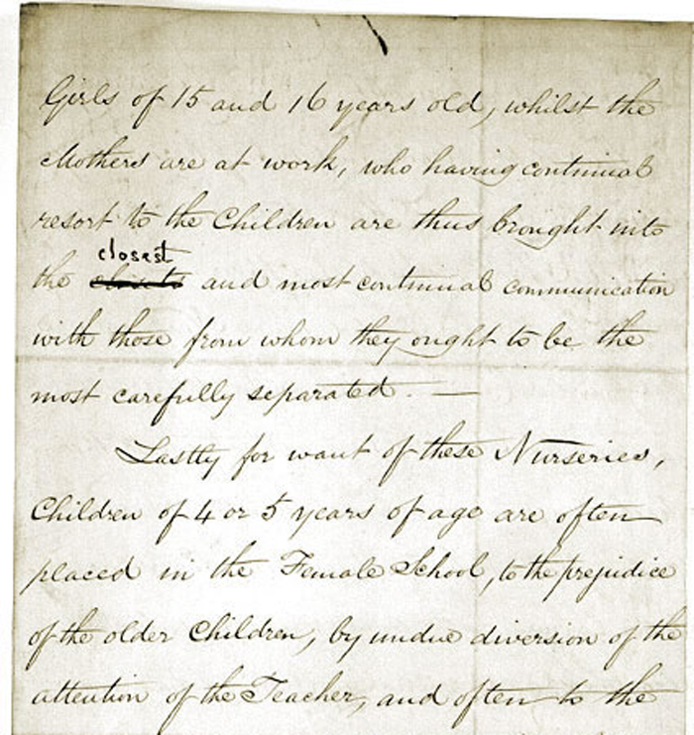

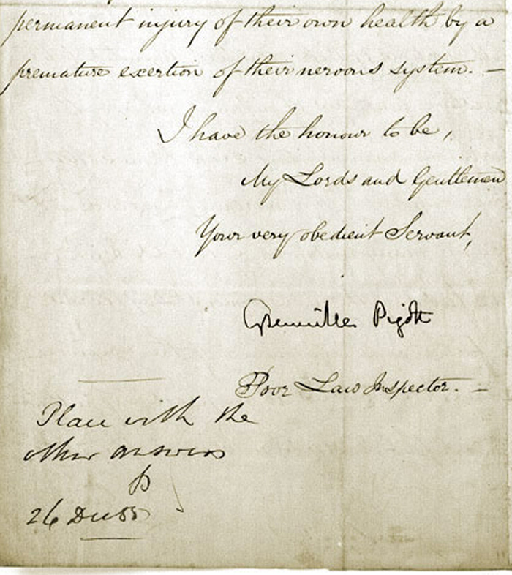

(PRO ref: MH 32/62)

