



1a. What sort of education are the children receiving in this school?
1b. List the different skills you can see that are being learnt?
1c. What sort of skills do you think a ragged school for girls would teach?

Ragged schools for girls and boys were set up from 1844 to educate poor children. The president of the Ragged Schools union was Lord Ashley, who later became Lord Shaftesbury. This is a print showing a Ragged School for boys.

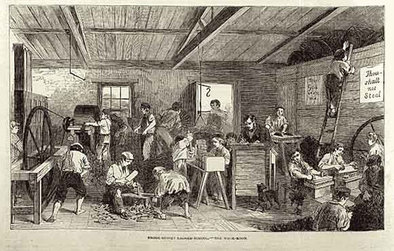

(PRO ref: ZPER 34/23, p.520)

