



2a. What did Ashley say happened when a woman went to work?
2b. What do you think Ashley believed about the status of men and women?

This is an extract from Lord Ashley’s Employment of Women and Children Report 1842. He was criticising the employment of women in coalmines and describing what happened in families where the wife worked.

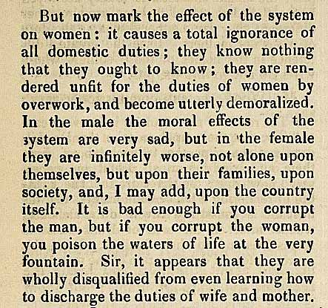

(PRO ref: ZHC 2/79, p.1335)

