



3a In what ways does Mr. Wood's statement support Lord Ashley’s opinions? See Source 2
3b Why do the mine owners prefer to employ women in the mines according to Mr. Sadler?
3c In your opinion, which of these two statements presents the strongest case against women working in the mines?

Witness statements included in Lord Ashley’s 1842 report. The first statement is made by Mr. Wood and the second is made by Mr. Sadler.

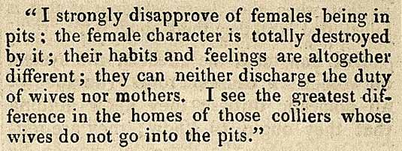

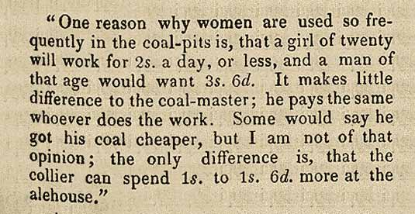

(PRO ref: ZHC 2/79, p.1338)

