



4a. What work were women doing in the coal mines?
4b. What was being criticised in the report?
Think about the evidence in sources 2, 3 and 4.
4c. Summarise the concerns that the report raises about women and girls working in the mines.
4d. Do you think that banning women from working in the mines was good or bad for their status?

This extract comes from the same report on mines published by Lord Ashley in 1842.
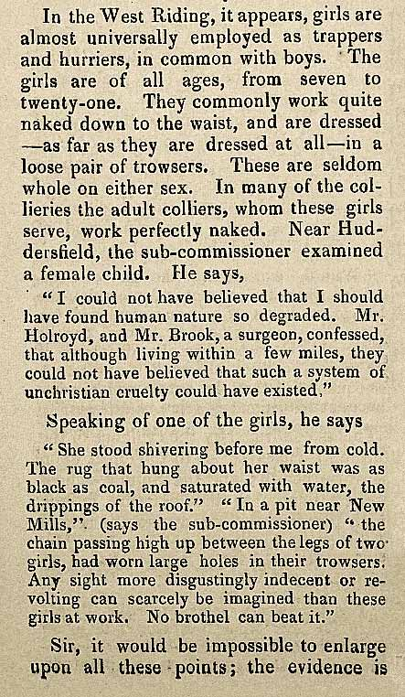

(PRO ref: ZHC 2/79, p.1327)

