



5a Write down a list of the different sorts of occupations that are given for the men in the workhouse.
5b Write down a list of the different sorts of occupations that are given for the women in the workhouse.(hint – check the ages- ignore young persons who are listed as scholars)
5c Which list is the longer?
5d What is the most common form of work done by the women? What does this tell you about employment of men and women in the middle of the nineteenth century?

This is the 1851 census return for a workhouse. It lists all the people who were in the workhouse on the night of 30th March 1851. On the first page are the names of the Master and the Matron and the other officials who ran the workhouse, but after that are the names of all the paupers.

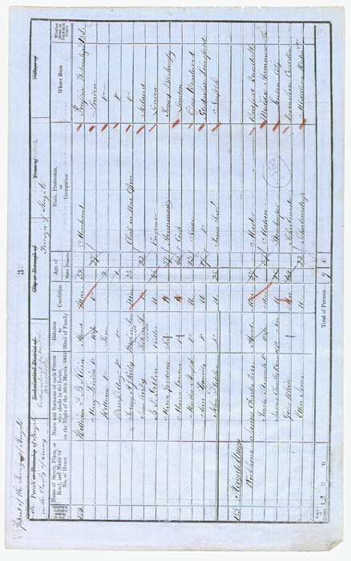

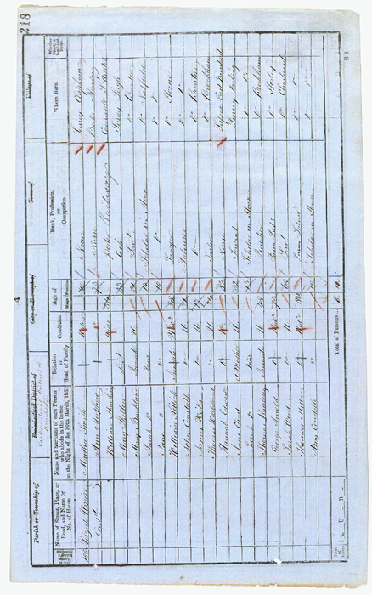

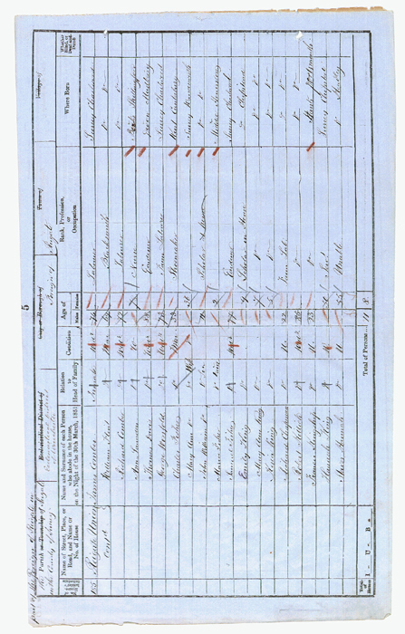

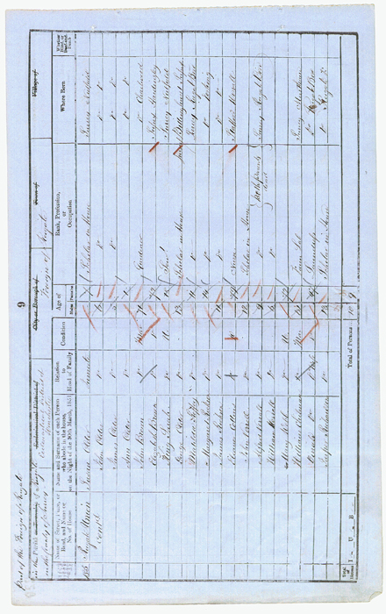

(PRO ref: HO 107/1599/1)

