H HHHHHHHHH
H





9a Why did Benjamin Disraeli believe that women should have the vote?
9b Why do you think he made this speech?

H

This is part of speech made by Benjamin Disraeli, the leader of the Conservative Party in the House of Commons in April 1866. He was speaking during a debate on the Second Reform Bill.
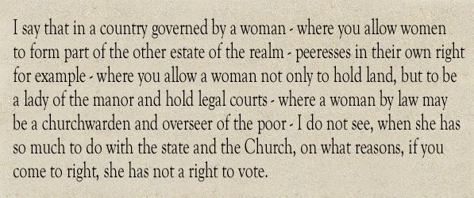

H HHH

