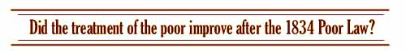

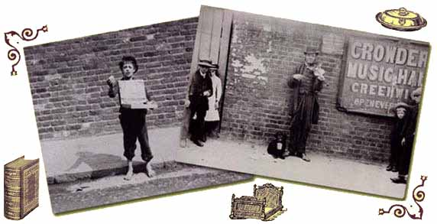

  Source 1:  Huddersfield workhouse report | More than 6,000,000 people visited the Great Exhibition in 1851. But what about the people who did not come? Among those who did not visit would have been poor people without means to support themselves. Had life improved for them since the introduction of the Poor law of 1834?  Before 1834 there was no one way of providing help for the poor. The local parish could build a workhouse if it wanted to and make the poor work for their keep. The parish could decide to give the poor money when they needed it. | 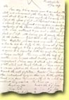  Source 2:  Huddersfield workhouse letter
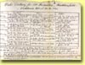  Source 3:  Huddersfield workhouse diet | Some used the Speenhamland System; this linked the amount of money handed out to the price of bread and the number of people in the family. But in 1834 all the different methods of helping the poor were abolished and replaced by a new one, the New Poor Law.  The New Poor Law was introduced by the Poor Law Amendment Act of 1834, which was based upon a report published in 1832. This report had been written by Edwin Chadwick. He wanted the poor to be helped to support themselves. He wanted children to be educated and taught a trade, but many of his ideas were forgotten when the Act was put into force. | 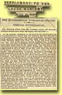  Source 4:  Huddersfield workhouse, 1848
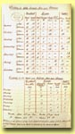  Source 5:  Reigate workhouse  diet | The Poor Law Amendment Act set up the Poor Law Commission in London, which was responsible for the organisation of Poor Relief throughout England and Wales. Parishes were grouped into 'Unions' and each Union had to build a workhouse.  Plans for the construction of Workhouses were provided by the Commission, which also sent out rules and regulations. Unions were told how Workhouses were to be run and how paupers, the term used for people who entered the Workhouse, were to be treated. | 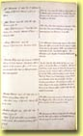  Source 6:  Helping the poor  in Reigate
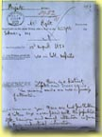  Source 7:  Reigate workhouse  report | After 1834, anybody who wanted help had to go into the Workhouse. Outdoor relief, giving money to people living in their own homes, was banned, unless the people were old or sick. In the Workhouse, the conditions were to be worse than anything that people might find outside; this was the idea of 'less eligibility'.  To make sure that Unions kept to the regulations, the Commission sent inspectors to every Workhouse at least once a year. These inspectors were called Assistant Commissioners. They wrote reports on all the Workhouses and sent them to the Commission in London.  The New Poor Law was supposed to be more efficient, but did the care of the poor really improve after the Poor Law Amendment Act? | 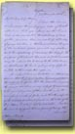  Source 8:  Poor Law letter


Edwin Chadwick

Edwin Chadwick was the man behind the Poor Law Amendment Act of 1834. He wanted to create a new system of poor relief, where people were trained to help themselves. He believed that the existing systems encouraged laziness by simply handing out money every week.
Chadwick intended that workhouses should offer education and training for young and old, but unfortunately his aims were misunderstood by many people, including some assistant Poor Law Commissioners; these were the men who were given the task of inspecting workhouses and making sure that they obeyed the regulations. They often believed that the main aim of the New Poor Law was simply to save money and punish the poor. Consequently, there were many examples of early workhouses being run as cheaply as possible. The result was that the poor were very badly treated. The most famous example of this was the Andover Scandal of 1846 where inmates fought over bones and gristle.
It was the fact that many of the poor in workhouses were so unhealthy, that encouraged Chadwick to investigate the public health in towns. This led him to publish his report in 1842.

This is a statement given by a 13 yr old boy to a commission about child workers which includes information about Halifax workhouse. It illustrates the role of the workhouse in a young orphan's life.

