
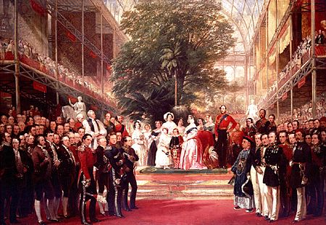

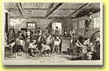  Source 1:  Ragged school |  | Most of the visitors to the Great Exhibition came on days when the tickets cost a shilling, or five pence. About 4,500,000 people came on these 'shilling days'. These were working people, who came from all over Britain. The first 'shilling day' was expected to lead to a great deal of trouble. One MP, Colonel Sibthorpe warned that there would be crime and disorder.  So on the first 'shilling day' there was a heavy police presence. But nothing happened. In the five and a half months that the Great Exhibition was open, only seven people were arrested and there was hardly any vandalism.  The men who policed the Great Exhibition were members of the Metropolitan Police force.  This force had been established in 1829 and its police constables were given the nickname 'Peelers' after Sir Robert Peel who was Home Secretary at the time. Until the 1820s the main emphasis in law and order was on punishment, because there were few police forces.  There were 400 offences that carried the death penalty, including picking someone’s pocket of anything worth one shilling (5p) or more and stealing anything worth £2.00. Sir Robert Peel abolished almost all of the capital offences (those that carried the death penalty) and also began to reform prisons, as well as setting up the Metropolitan Police Force. | 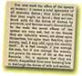  Source 2:  Report on  working women
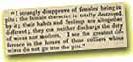  Source 3:  Report on  women in mines |  | Peel wanted to put the emphasis upon preventing crime, rather than punishing criminals. Some of the novels of Charles Dickens, who was writing in the 1830s and 1840s, show how lawless the streets of British cities could be.  In ‘Oliver Twist’ Fagin runs a gang of pickpockets, and Bill Sykes is a violent and dangerous criminal. In ‘Great Expectations’, Pip is befriended by the convict Magwitch, who had escaped from a hulk.  At first the Police Force was not very popular. People were very concerned that the new police should not be like the military and therefore great care was taken to ensure that police constables did not look like soldiers.  This is why peelers wore top hats instead of helmets and carried truncheons instead of rifles, although cutlasses were available for emergencies! | 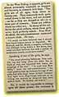  Source 4:  Report on  children in mines
  Source 5:  Workhouse,  1851 |  | The success of the Metropolitan Police Force, however, led other parts of the country to set up their own forces. However, it did not become compulsory for counties and boroughs to have police forces until 1856. The duties of the police were extended as more and more laws were passed.  For example the 1872 Licensing Act made them responsible for supervising public drinking places. Policing was not the only aspect of law and order that changed during the Victorian period.  The ways in which criminals were punished were also changed. 1857 saw the end of Hulk ships. These were anchored ships, which held prisoners who were either awaiting transportation to the colonies, or were used to carry out public works, such as clearing the River Thames. | 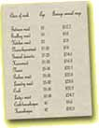  Source 6:  Servants' wages,  1890s
  Source 7:  Article on  women's work  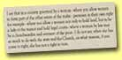  Source 9:  Disraeli on  votes for women |  | The transportation of criminals gradually declined and the last convict ship arrived in Australia in 1868. These changes led to a new prison building programme based upon the model prison at Pentonville. Inside these new prisons, prisoners were separated, forbidden to communicate with each other and given meaningless work to do. But did these changes make a difference? | 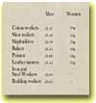  Source 8:  Men & women's  wages, 1906

H HHH

H HHH

