

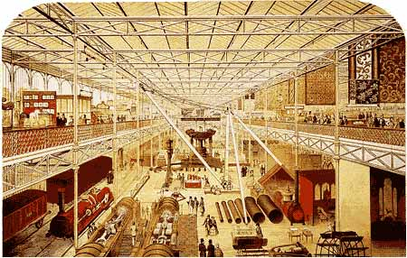

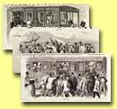  Source 1:  Epsom races |  | Most of the working people, who came to the Great Exhibition on the 'Shilling Days', arrived by rail, often from the north of England. King's Cross station had been opened in 1850 and there were nearly 7,000 miles of track linking London with the towns of the Midlands and the North.  The most popular way of getting to the Great Exhibition was by buying a ticket that included a return rail journey and entry. These could cost 4, 5 or 6 shillings. Hundreds of thousands of people took advantage of these day trips, which were the idea of Thomas Cook. | 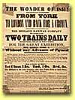  Source 2:  Great Exhibition  1851
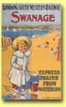  Source 3:  Swanage seaside  resort |  | Thomas Cook started his business in 1841, but the Great Exhibition gave him his big chance.  He booked trains from all over Britain to take people to the Great Exhibition and charged them a fixed price for the return trip and the entry ticket. Overnight he had invented the 'Day Out'. As Cook’s business grew he began to offer excursions to more and more places, including trips to other European countries. When Thomas Cook’s son took over the family business he increased the tours abroad and offered a wider choice of excursions. Soon the railway companies began to run their  own excursions.  At first, railway companies tried to avoid catering for the masses and preferred to run trains that only offered second and first class carriages. They also tried to avoid stopping their trains at every station. But in 1844 the Railways Act stated that at least one train a day must stop at every station and include third class carriages. Now large numbers of Victorians could afford to travel. Rich people could even take their horses with them on special hunting excursions! | 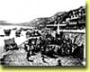  Source 4  Beach, Isle of Wight
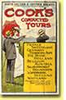  Source 5:  Tourist poster |  | The railways were to make a huge difference to the leisure activities of the Victorians. Not only were opportunities for holidays and day trips increased, sporting events also grew in popularity. Special trains and trips were run to take people to the races, cricket matches or the FA Cup Final, which was held for the first time in 1872. It was not only spectators that benefited, the football clubs that were being started in many of Britain’s Happy cities could now travel away to play against each other. | 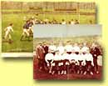  Source 6:  Footballers
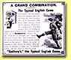  Source 7:  Cocoa Advert |  | In 1888 the Football League was founded. This was made up of professional teams. It would have been impossible for the first teams to have travelled to play away matches without regular trains. So the railways were very important in the development of professional football in Britain.  But many of these developments only affected the better off people in Britain. For most working people, the important changes were the cheap day returns that many railway companies started to offer.  In 1871 Bank Holidays were introduced and so began the great British tradition of the day at the seaside, along with sticks of rock, candy-floss, walks along the pier, fun-fair rides and fish and chips. The first fish and chip shops appeared in the 1860s. |   Source 8:  Soap advert


The Railways

The Victorian age was the greatest period of the railways in Britain. The railways almost completely wiped out all other forms of transport and made long distance travel possible for large numbers of people for the very first time. Every town of any importance was linked by the national network, however many smaller towns were not connected. | 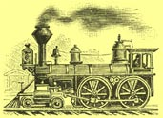
This meant that people could, for the first time, live miles away from their places of work. Around London, suburbs began to develop for the first time and people travelled up to twenty miles in to London to work every day. Colonel Charles Sibthorp, who was a great opponent of the Crystal Palace, was also opposed to the development of railways. However, he dropped his opposition when he realised that it would be possible for him to travel to and from his constituency in Lincoln much more quickly.
But people could also travel in the opposite direction and for the first time seaside resorts began to flourish. In the past, places like Brighton had only been for the wealthy, from the mid-nineteenth century more and more people were able to enjoy the delights of the seaside and a great British tradition was created.

