

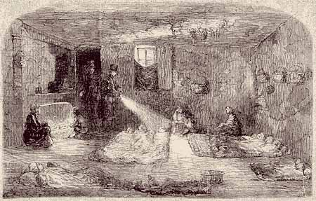

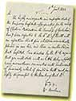  Source 1:  Cholera hospital,  1832 |  | Prince Albert married Queen Victoria in 1840 and they had nine children, but in December 1861 he fell ill and died. Prince Albert had caught TYPHOID, a disease that is caused by drinking either dirty water or milk, or eating dirty food. The usual cause of typhoid was allowing drinking water to be polluted by sewage.  The death of her husband was a great shock to Queen Victoria. How could one of the most important people in Britain die from a disease like this? Was this common? Were rich and poor just as likely to die from diseases like this at the time of the Great Exhibition? | 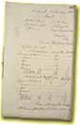  Source 2:  Meeting about  cholera, 1832
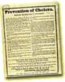  Source 3:  Poster on  cholera, 1848 |  | The big killer disease of the mid-nineteenth century was CHOLERA which was caused in a similar way to the disease Prince Albert had died of. Cholera had arrived in Britain for the first time in 1831, probably arriving on ships bringing imports from China.  Doctors had little idea about the causes of cholera. Most accepted the miasmatic (read on!) theory of disease. They believed that diseases were caused by the air somehow being polluted by waste. This came about because severe outbreaks of disease often happened in hot summers when there was a great deal of rubbish lying in the streets. As the rubbish rotted, it gave off a stronger and stronger smell. This, many doctors believed, caused disease. | 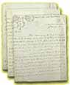  Source 4:  Cholera epidemic
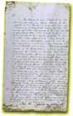  Source 5:  Health of the  town of  Ormskirk |  | Cholera was most dangerous in the new industrial towns of the north or in the centre of big cities like London. Here people lived in crowded housing. Most people got their water from a tap in the street and often the supply was pumped out of a nearby river. This river could easily be used for sewage disposal at the same time. In London, one water company drew water out of the River Thames from a point right next to the outlet of the Great Ranelagh Sewer. | 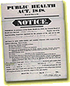  Source 6:  Public health  poster, Ormskirk
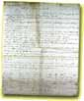  Source 7:  Petition from  Ormskirk |  | In the new industrial towns, cholera was even more dangerous because many of the houses had been built quickly with no attempts at planning. Often there was no sanitation and no fresh water. In one street in Bolton the people used a trench at the back of the houses as a toilet, which was cleared out and the mess stacked up against the end wall of the last house. The mess was taken away every six months.  There was a second big outbreak of cholera in 1848, a third in 1853 and a fourth in 1866. Each time thousands of people died swiftly and in terrible pain. They suffered violent vomiting and diarrhoea, coupled with very bad stomach pains. The actual cause of death was often dehydration (not enough water). | 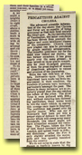  Source 8:  Cholera outbreak,  1853


Edwin Chadwick

In 1842 Edwin Chadwick published his 'Report on the Sanitary Conditions of the Labouring Population of Great Britain'. He had surveyed different areas around the country and calculated the average life expectancy of people from different classes and areas. The results were startling to say the least.
Chadwick claimed that people living in the countryside lived far longer than people in towns. He compared Rutland, a rural county with no large towns, with the new industrial cities of the north.
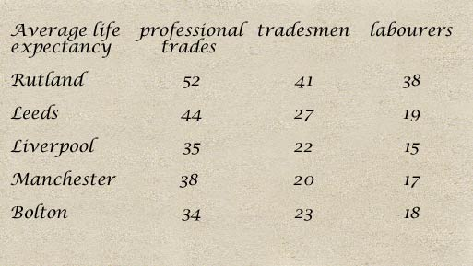

Chadwick's report led to the setting up of a Royal Commission and then to the Public Health Act of 1848. He became one of the Commissioners.
Unfortunately many people found Chadwick rather rude and he often provoked opposition. In 1854 he was forced to retire. This letter was sent to 'The Times' to explain why he was unpopular.
' We prefer to take our chance with cholera than be bullied into health. There is nothing a man hates so much as being cleansed against his will or having his floor swept, his hall whitewashed, his dung heaps cleared away and his thatch forced to give way to slate. It is a fact that many people have died from a good washing.'
John Snow (1813-1858)
John Snow was the eldest son of a farmer and born at York on 15th March 1813. He was educated at a private school in York until the age of fourteen, when he was apprenticed to a surgeon living at Newcastle-on-Tyne. He worked as surgeon in the mines and later as unqualified assistant during the cholera epidemic of 1831-2. Snow continued his medical training in London. In October 1838 he became a licentiate of the Society of Apothecaries, having been admitted a member of the Royal College of Surgeons of England in May 1838. He graduated as an M.D. of the University of London on 20 December 1844, and in 1850 he was admitted a licentiate of the Royal College of Physicians.
Snow's great breakthrough theory was that cholera spreads through means of an impure water supply. He outlined his ideas in an essay about the communication of cholera which was published in 1849, and awarded a prize by the Institute of France. In 1855 a second edition was published, with a much more detailed investigation into the water supply in certain districts of South London during in the epidemic of 1854.
Snow was also interested in the properties of ether, then newly adopted in America as an anaesthetic. He made great improvements in the method of giving patients the drug. He obtained permission to demonstrate his results in the dental out-patient room at St. George's Hospital surgery which was highly successful. Nevertheless, Snow appreciated the value of other anaesthetizing drugs, notably chloroform. He gave this to Queen Victoria on 7 April 1853, during the birth of Prince Leopold, and again on 14 April 1857 at the birth of Princess Beatrice. Snow died unmarried on 16 June 1858, and was buried in the Brompton cemetery.

