

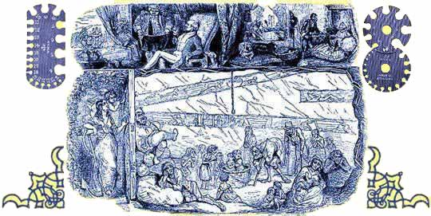

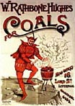  Advert for coal |  |  | The visitors who came to the Great Exhibition on the shilling days were often working people from the Midlands and the North. They would have worked in factories, coalmines and on the railway. 4 shillings would have been at least a day's pay for many of them. What was it like to work in Victorian Britain?  Did working people share in the enormous wealth and prosperity of the Great Exhibition?  In the middle of the 18th century, most coalmines in Britain were near the surface and mining was a small scale industry where families worked together in bell-pits or adits. But in the second half of the century surface coal began to run out and mines became deeper. | 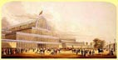  Front of Crystal Palace
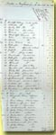  Source 1:  Miners killed,  1851 |  | Deeper mines were much more dangerous. There was not only a much greater risk of rock falls and flooding, but miners could also run into pockets of gas underground that could lead to explosions or suffocation.  Miners had virtually nothing to protect themselves against the increased dangers. Some took canaries underground to warn them against gas, if the canary stopped singing that was a sign that gas was present. To try to prevent the roof caving in, miners left columns of coal standing. This was known as the 'pit and stall' method. But coal can collapse very easily, so this was not a safe method of working. |  | 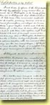  Source 2:  Mine accidents, 1851
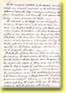  Source 3:  Report on  mine deaths,1851 |  |  | Ventilation became a serious problem as miners went deeper and deeper underground. The earliest solution was digging a down-shaft and an up-shaft. At the bottom of the up-shaft a fire was set ablaze, which sent hot air up the shaft. This in turn sucked fresh air into the down-shaft. To make sure that the fresh air reached all parts of the mine, trapdoors were put in all the galleries of mines, which were opened and closed as the coal trucks passed through. This ensured that there was a constant supply of air throughout the mine. The trapdoors were opened by small boys (trappers), whom sat in total darkness listening for the sound of the corves (coal trucks/sleds). | 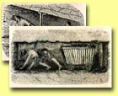  Source 4:  Child miners
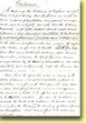  Source 5:  Mine report  conclusions, 1851 |  |  | The most serious danger of all was caused by the need for light. At first miners carried candles underground, but this proved to be very dangerous, as pockets of gas could ignite without warning. In all, it was dark, dangerous and deadly work. Throughout the 19th century more than a thousand miners were killed every year in Britain. | 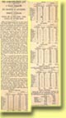  Source 6:  News on mine accidents


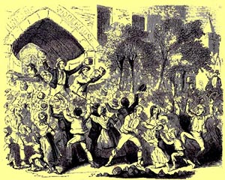  An attack on a workhouse in Stockport | 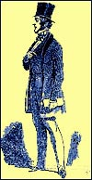 Lord Shaftesbury (formerly known as Lord Ashley)
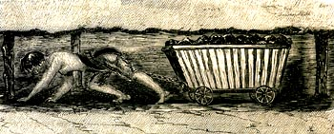  Trammers pulled sledges of coal | 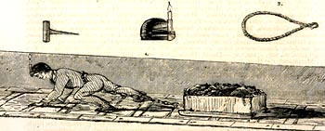
Lord Shaftesbury spent most of his life trying to improve the lives of the poorest and most
oppressed people in Britain, but his most famous work was in the preparation of the
'First Report of the Children's Employment Commissioners: Mines and Collieries' in 1842.
In the report, Shaftesbury printed many pictures of working conditions in mines and also included accounts of interviews with workers.
Look at these pictures, and read the accounts from the report in source 4 of the Industrial Nation.

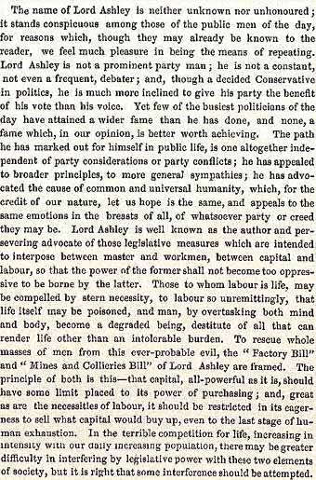
Newspaper description of Lord Ashley

