
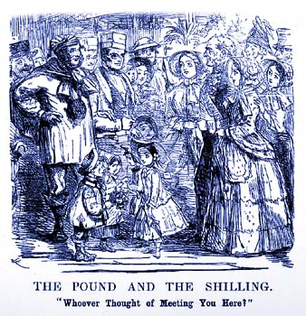

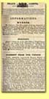  Source 1:  Police gazette,  1845 |  | Most of the visitors to the Great Exhibition came on days when the tickets cost a shilling, or five pence. About 4,500,000 people came on these 'shilling days'. These were working people, who came from all over Britain. The first 'shilling day' was expected to lead to a great deal of trouble. One MP, Colonel Sibthorpe warned that there would be crime and disorder.  So on the first 'shilling day' there was a heavy police presence. But nothing happened. In the five and a half months that the Great Exhibition was open, only seven people were arrested and there was hardly any vandalism.  The men who policed the Great Exhibition were members of the Metropolitan Police force.  This force had been established in 1829 and its police constables were given the nickname 'Peelers' after Sir Robert Peel who was Home Secretary at the time. Until the 1820s the main emphasis in law and order was on punishment, because there were few police forces.  There were 400 offences that carried the death penalty, including picking someone’s pocket of anything worth one shilling (5p) or more and stealing anything worth £2.00. Sir Robert Peel abolished almost all of the capital offences (those that carried the death penalty) and also began to reform prisons, as well as setting up the Metropolitan Police Force. | 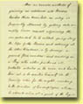  Source 2:  Breaking into  a house
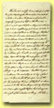  Source 3:  Breaking into  a warehouse |  | Peel wanted to put the emphasis upon preventing crime, rather than punishing criminals. Some of the novels of Charles Dickens, who was writing in the 1830s and 1840s, show how lawless the streets of British cities could be.  In ‘Oliver Twist’ Fagin runs a gang of pickpockets, and Bill Sykes is a violent and dangerous criminal. In ‘Great Expectations’, Pip is befriended by the convict Magwitch, who had escaped from a hulk.  At first the Police Force was not very popular. People were very concerned that the new police should not be like the military and therefore great care was taken to ensure that police constables did not look like soldiers.  This is why peelers wore top hats instead of helmets and carried truncheons instead of rifles, although cutlasses were available for emergencies! | 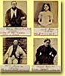  Source 4:  Photos of  prisoners
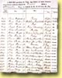  Source 5:  List of  prisoners, 1849 |  | The success of the Metropolitan Police Force, however, led other parts of the country to set up their own forces. However, it did not become compulsory for counties and boroughs to have police forces until 1856. The duties of the police were extended as more and more laws were passed.  For example the 1872 Licensing Act made them responsible for supervising public drinking places. Policing was not the only aspect of law and order that changed during the Victorian period.  The ways in which criminals were punished were also changed. 1857 saw the end of Hulk ships. These were anchored ships, which held prisoners who were either awaiting transportation to the colonies, or were used to carry out public works, such as clearing the River Thames. | 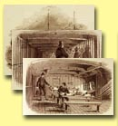  Source 6:  Convict ship,  1846
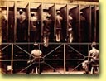  Source 7:  Treadmill |  | The transportation of criminals gradually declined and the last convict ship arrived in Australia in 1868. These changes led to a new prison building programme based upon the model prison at Pentonville. Inside these new prisons, prisoners were separated, forbidden to communicate with each other and given meaningless work to do. But did these changes make a difference? |   Colonel Sibthorpe's  views on the  Great Exhibition


The Metropolitan Police

At the beginning of the nineteenth century there were only two police forces in Britain. One was the Bow Street Runners, which was a detective force that had been set up in 1749; the other was the City of London Police Force, which had been set up in 1798. In the remainder of the country, law and order was in the hands of the local magistrates, who could enlist special constables or call in the army. In local villages there could be Parish Constables or night-watchmen. | 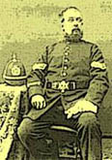
The Metropolitan Police Force was set up in 1829 by the Home Secretary Sir Robert Peel. He had already set up a police force in Ireland in 1822. There were 2,800 officers headed by two commissioners. As well as being called 'Peelers', they were also known as 'Bobbies'.
The early days of the Metropolitan Police Force were not very good. Of the first 2,800 recruits, 2,328 were dismissed from the force for breaking regulations.
In 1842 a plain clothes branch was set up with eight members. This aroused great public opposition. There were many protests that it would be unfair to have policemen out of uniform, as the public would be unable to identify them. But eventually the Criminal Investigation Department was established in 1878.

Prisons

In the eighteenth century prisons were often run privately and warders charged the inmates for food and other services. Extra payments could also lead to separate rooms, and frequent visitors. Wealthy prisoners could live almost as well in prison as they could outside.  But for the poor, the situation was very different. Prisoners were squashed into rooms, which could hold fifty or more people. There was no hygiene and typhus, known as jail fever, was widespread.  The first attempts to reform prisons came in the 1770s when John Howard, a magistrate, visited prisons and then passed an Act of Parliament that led to warders being paid a salary rather than charging fees. Elizabeth Fry, who campaigned to improve prison conditions, began to visit Newgate Prison in the early nineteenth century and her efforts led to the setting up of Holloway prison for women.  But the most important changes in prisons came in the middle of the nineteenth century, when a new design of prison was introduced. This was called the 'separate system'. Here prisoners were kept in separate cells in wings radiating out from one central block. This enabled the warders to keep an eye on the prisoners as easily as possible. | 