



1a How many differences can you see between the railway carriages that the different classes of passengers used?
2a What do you think was the artist’s opinion of the people in each class of carriage?
3a Why do you think there are no more third class carriages on trains today?

These engravings are taken from the Illustrated London News, 22nd May 1847. They show first, second and third class passengers travelling to Epsom races.

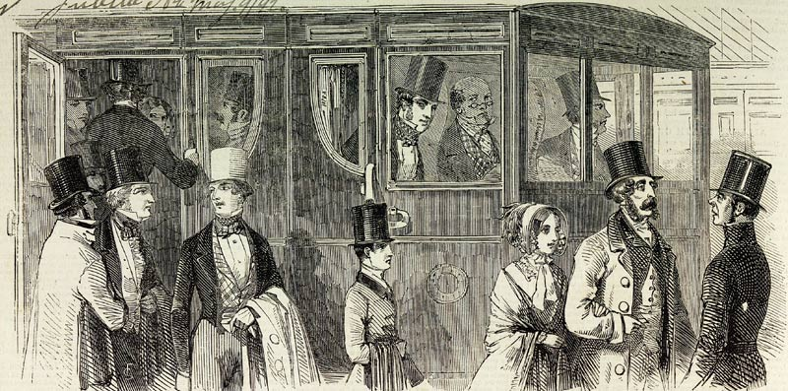

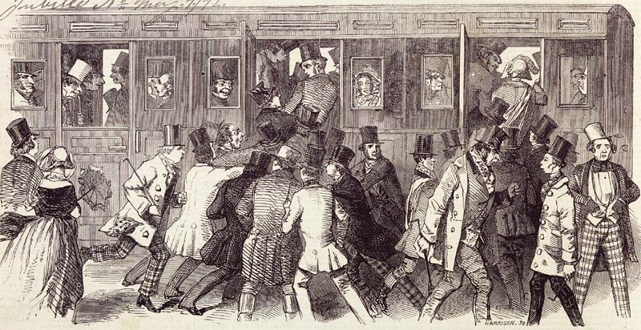

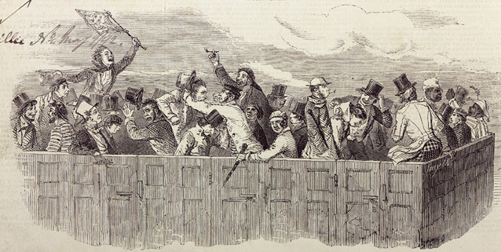

(PRO ref: ZPER 34/10)

