



2a Can you find any evidence in the poster that different social classes were being encouraged to visit the Great Exhibition?
2b Why do you think there are such differences in the prices quoted on the poster? Look back at source 1 to help you with this.
2c Can you find any evidence in the poster that the safety of train travel was a concern for travellers?

Poster advertising train journeys to the Great Exhibition, 1851

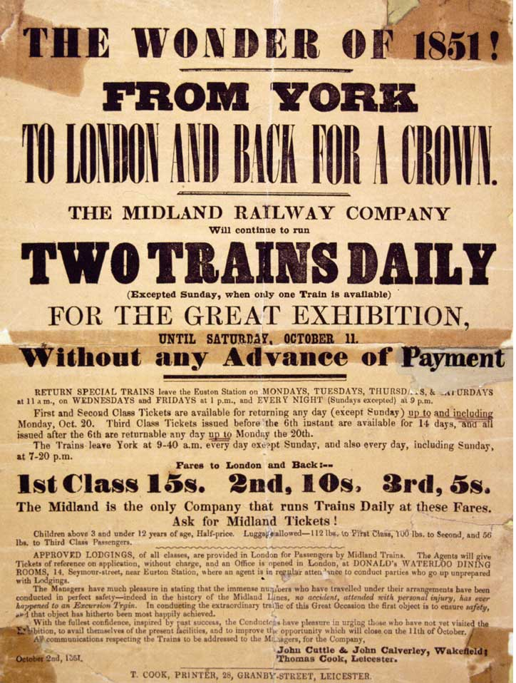

(Thomas Cook Archive)
(PRO ref: 87/53)

