



4a Why do you think there are so many people on the beach?
4b How are they dressed?
4c The Victorians were very private when it came to undressing. Can you work out where they would get changed to go for a swim.
Look back at source 3
4d Can you see any similarities between sources 3 and 4?
4e Do you think source 3 gives a good impression of what Victorian seaside resorts were like?

Photograph of the beach on the Isle of Wight.

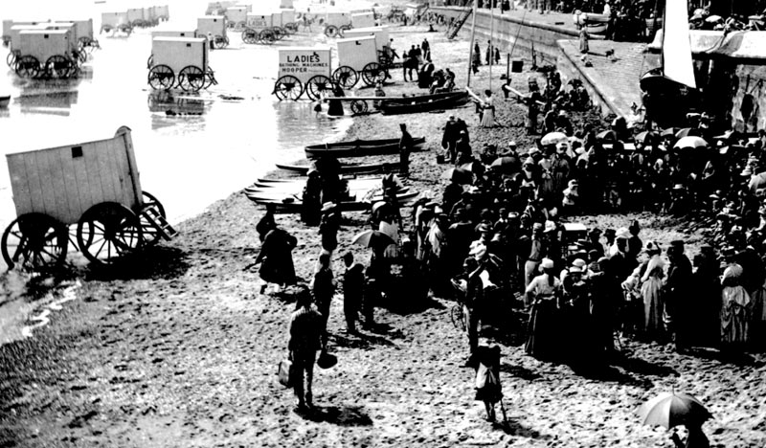

(PRO ref: COPY 1/381)

