



5a Look carefully at the poster. What sorts of people would be able to go on the tours shown?
5b What changes do you think have happened to Thomas Cook’s business since 1841? See if you can find at least three. You might want to read introduction text first.
5c How important were the railways for Thomas Cook’s business?

Poster advertising some of the different tours offered by Thomas Cook
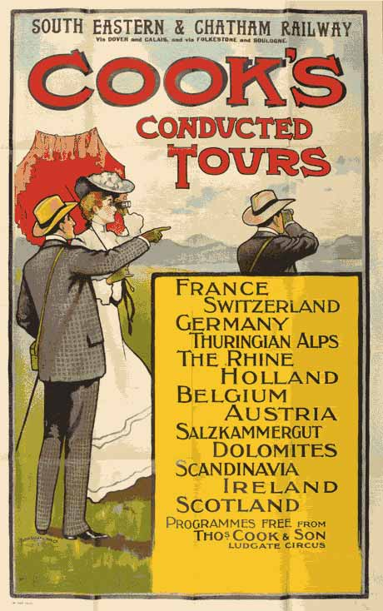

(Thomas Cook Archive)

