



6a Look carefully at the photograph and the painting and list as many differences that you can think of between the footballers of 1870 and 1899.
6b Now list the differences between Victorian Footballers (use the photograph) and those of today.
6c What evidence is there in the photograph that football had become a popular spectator sport.
6d Explain what impact the railways had on leisure activities such as watching sport.

6i Painting of England versus Scotland football match c.1870,
Richmond Park

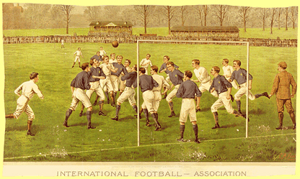

(PRO ref: COPY 1/120)
6ii Photograph of the England football team before playing against
Scotland, 1899.

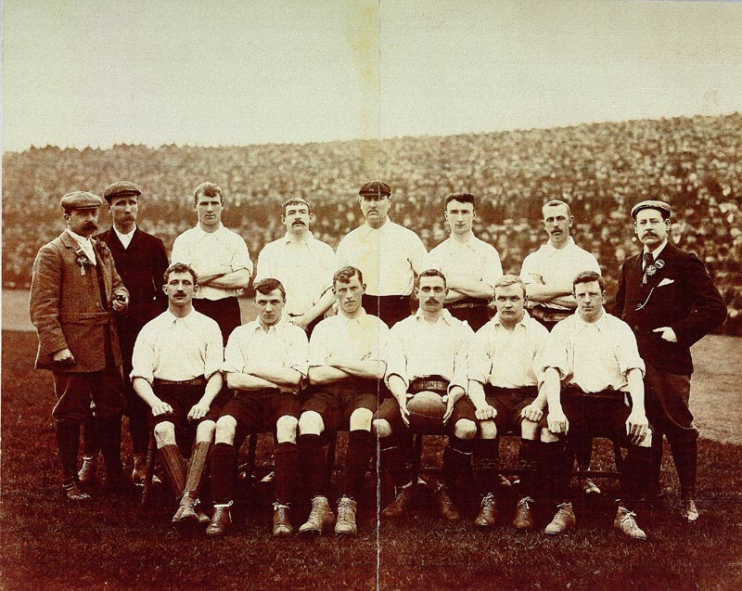
(PRO ref: COPY 1/452)

