



7a Explain what sport you think the people shown in the advertisement are taking part in.
7b Why were these people shown in the advertisement?
7c What does this tell us about the importance of sport to Victorians?
Look carefully at the advertisement and look back at source 6
7d Why do you think that Cadbury’s chose to advertise their product like this?

An Advert for Cadbury’s Cocoa, 1896
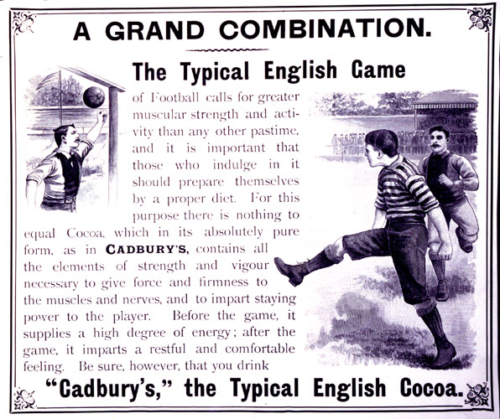
(PRO ref: COPY 1/119, f.276)

