



8a. Why do you think Hudson’s used W.G. Grace to advertise their product?
8b. Look at sources 6, 7 and 8 and explain if you think sport was popular in Victorian Britain.

This is an advertisement for Hudson’s washing soap. It features a famous cricketer from the Victorian Era, W. G. Grace. He began playing in 1865 and by the time he retired he had scored 54,211 runs in first class games and taken 2, 808 wickets. Grace stopped playing First Class cricket in 1908.
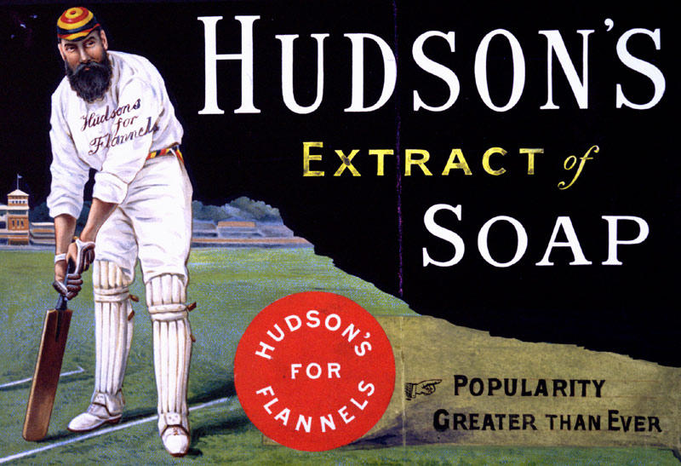

(PRO ref: COPY 1/119, f.221)

