



1a Why has the letter been written?
1b What had happened in the hospital?
1c Would the treatment received in the hospital have helped to stop cholera spreading?

This is a letter written on 5th January 1832. It was sent from the Board of Health to the Newcastle Board. The writer is talking about conditions in Gateshead hospital.

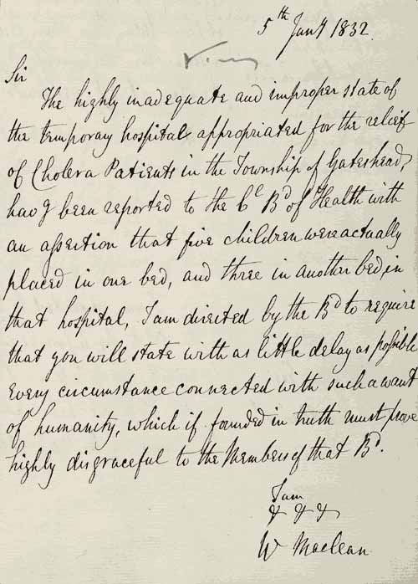

(PRO ref: PC 1/93)

