



2a How many new cases were reported?
2b How many of the deaths were reported?
2c How many cases of cholera were there altogether?
2d How many people had died?
2e Approximately what percentage of people who caught cholera actually died from the disease?

These are the minutes of a meeting of the Board of Health held on 13th January 1832. It includes a report of the numbers of cases of cholera in Sunderland, Newcastle and Gateshead.
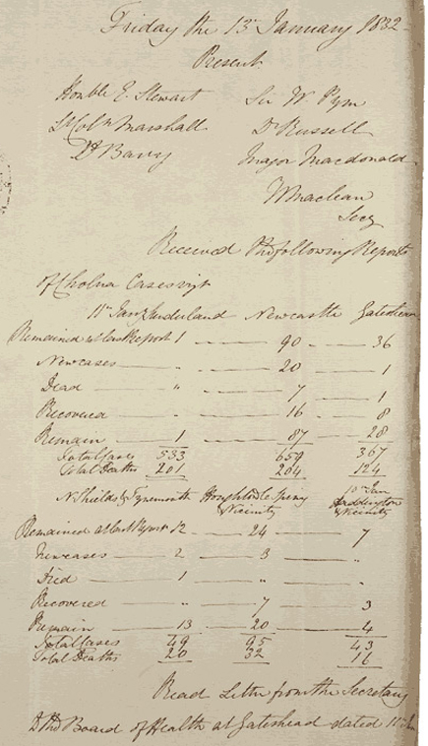
(PRO ref: PC 1/105)

