



3a What is the poster saying it can help prevent?
3b The poster gives advice on how to avoid getting cholera. Some advice is good, some is bad.
i) Write down three good pieces of advice.
ii) Write down three bad pieces of advice (choose the worst!).
3c What else is the poster offering apart from advice?
3d The poster suggests two things that can be bought for protection against cholera. What were they? Would either of these have been of any use?

This is a poster that was put up in London in 1848, during the second outbreak of cholera.

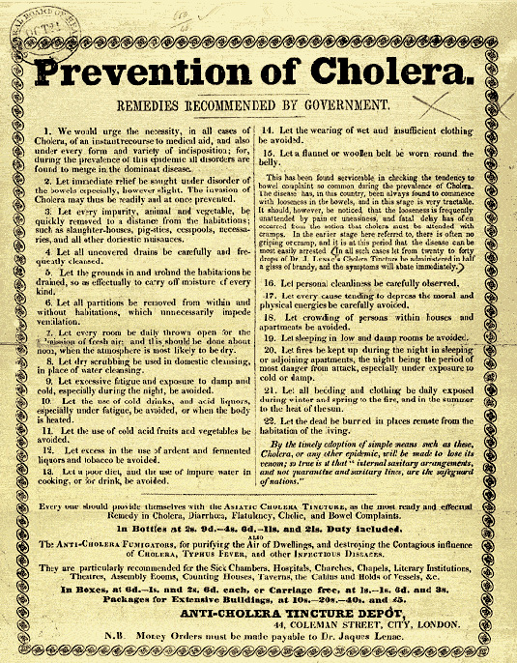

(PRO ref: MH 13/245)

