



4a Where does he say the worst outbreaks of cholera took place?
4b Where were there not many, if any, cases of cholera?
4c How does he explain the differences?
4d What does he believe were the causes of cholera?
4e Do you think that people in 1848 had any better idea of the ways to treat cholera than they had had in 1832? (Source 1)
4f If all the suggestions made in source 3 and 4 had been followed, would this have prevented an outbreak of cholera?

In October 1848 this letter was written to the General Board of Health (set up by the Public Health Act 1848). The writer is describing the cholera epidemic of 1832 which he had witnessed.

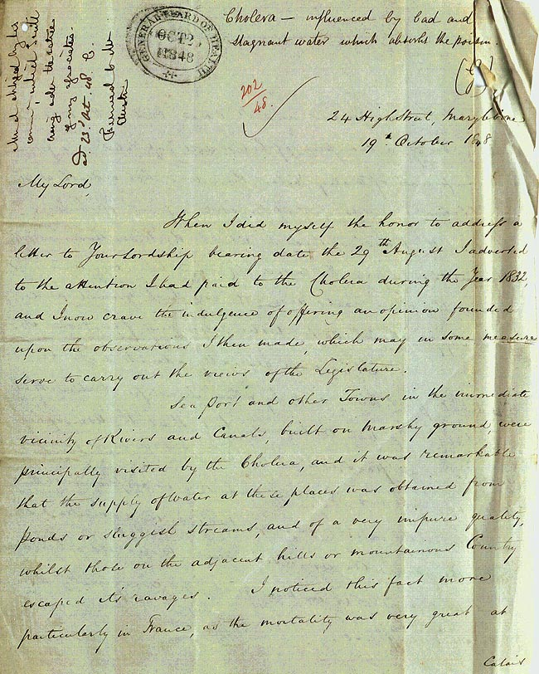

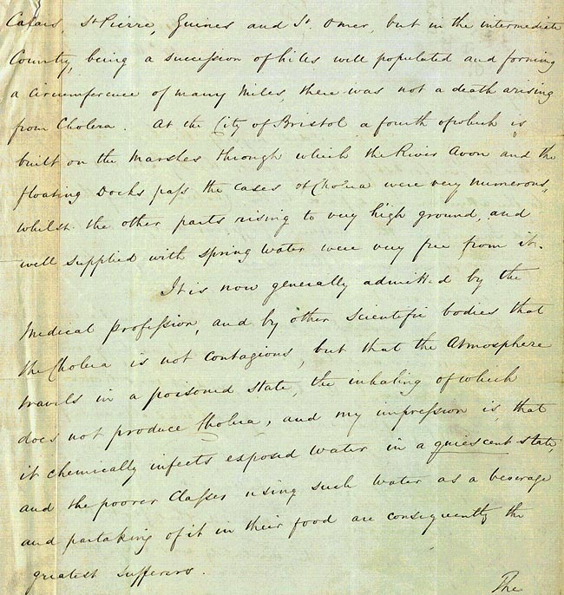

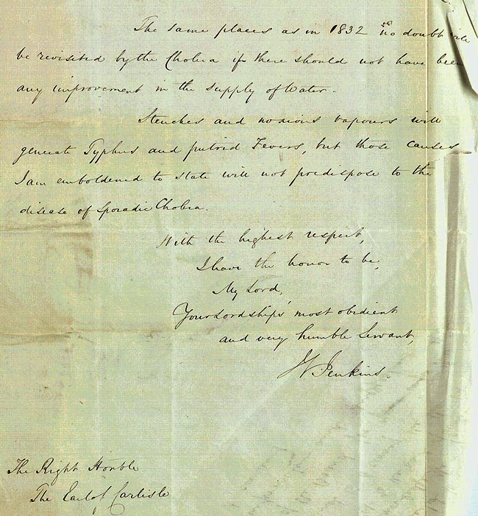
(PRO ref: MH 13/245)

