



5a How many people had signed the petition in Ormskirk?
5b What are the reasons for sending the letter?
5c Which of the reasons would help prevent cholera? Which would not?

This is a letter written by the Chairman of the Sanitary Committee of Ormskirk to the General Board of Health in 1848. Towns could ask the General Board to set up a Local Board, but at least ten percent of the ratepayers had to sign a petition. The General Board would then send an inspector to town to inspect the sanitary state of the town.

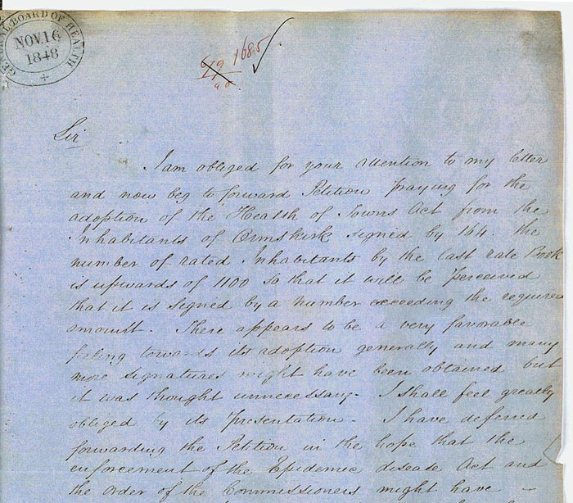

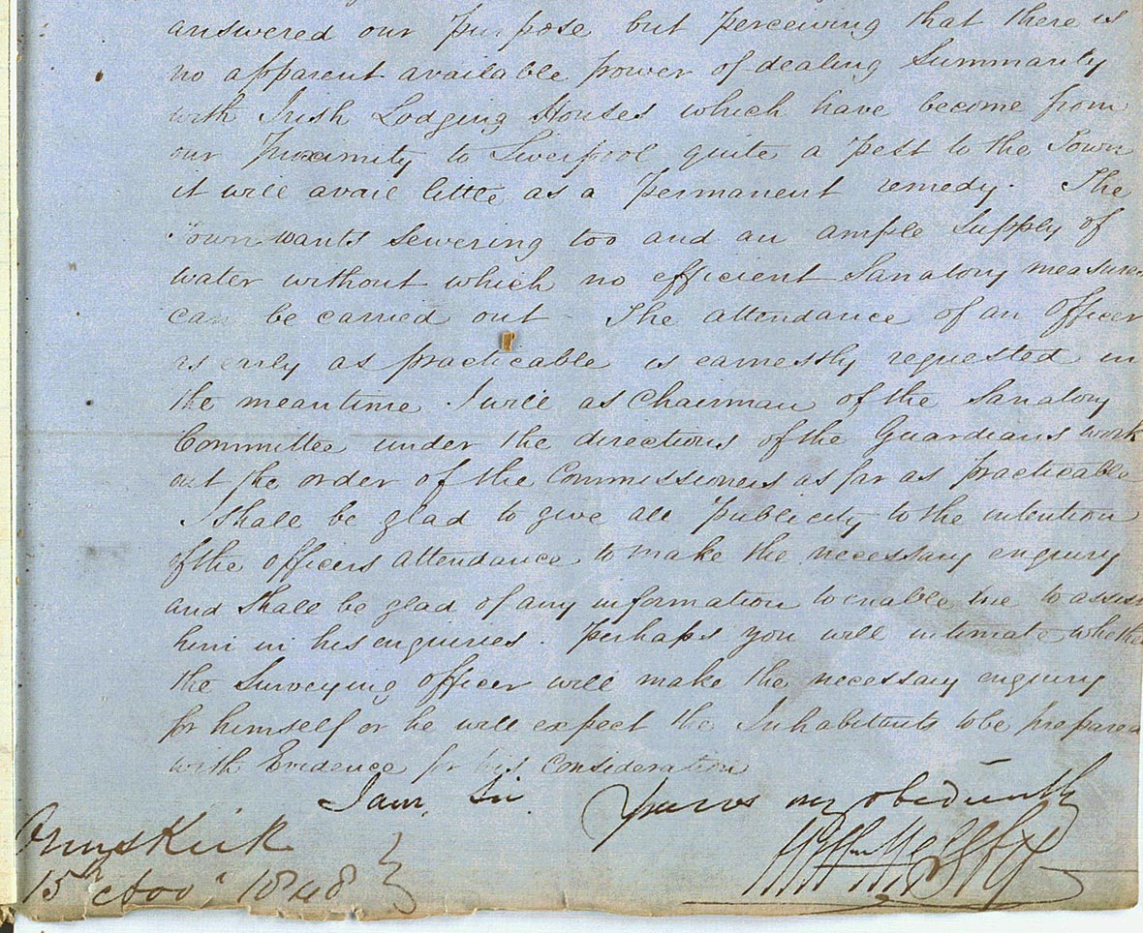

(PRO ref: MH13/138)

