



6a What was the inspector going to look into?
6b Would his enquiries have helped to identify possible causes of cholera outbreaks in the town?
Look back at source 5
6c In what ways do these sources suggest that cholera was being taken more seriously in Britain?

This poster appeared in the town of Ormskirk in Lancashire in October 1848. It was signed by the inspector appointed for Ormskirk.
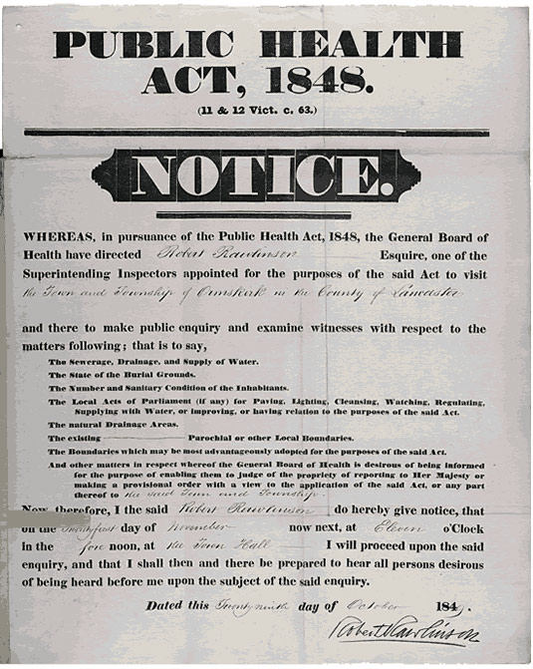
(PRO ref: MH 13/138)

