



7a. Why was this petition sent? What were the people objecting to?
7b. Why do they believe that a Local Board of Health is not needed?

A petition sent by people in Ormskirk to the General Board of Health.

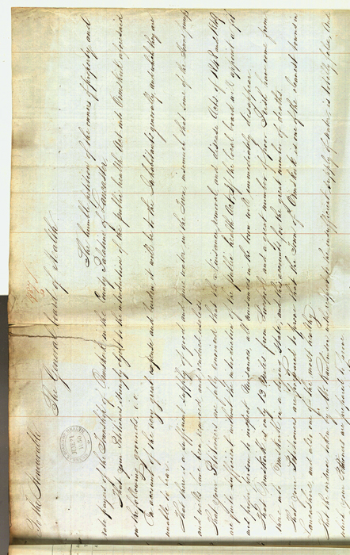

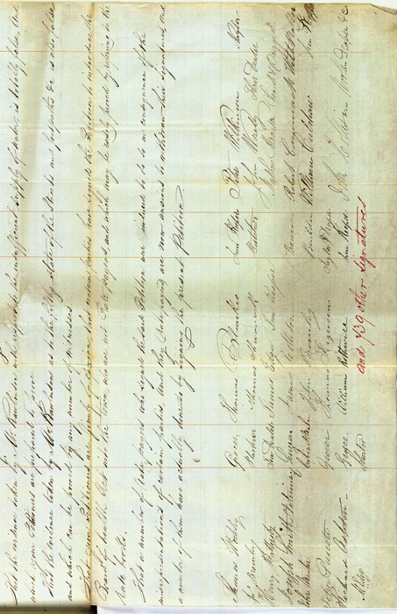
(PRO ref: MH 13/138)

