



8a. What is the main reason for the outbreak of cholera suggested in this source?
8b. What conditions in Newcastle upon Tyne and Gateshead caused cholera to spread so easily?
8c. The end of the source says that some men are against efforts to improve living conditions in the worst parts of the city. Can you explain this?

This is part of newspaper report from October 1853; this was at the time of the third outbreak of cholera.
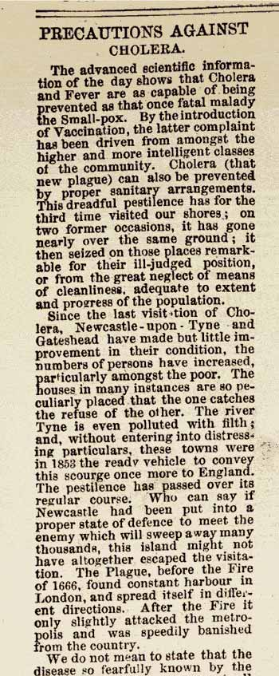 | 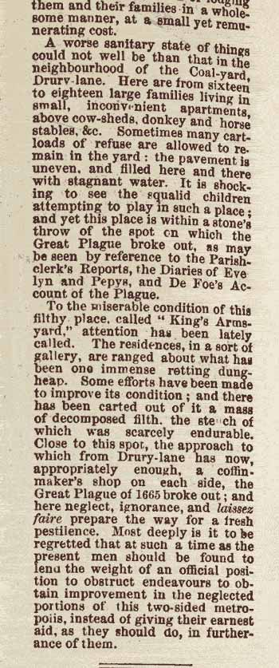

(PRO ref: ZPER 34/23)

