



1a There are five causes of deaths in mines in this report. They are given at the top of the five columns. What are they?
1b Look at the 'sundries' column. What causes of death are included here? Look at the details given on the left of the report. Which was the most common cause of death in 1851?
1c The report states that 15 miners were killed in falls of coal and stone. Is he correct? Count up the number of recorded deaths.

1d How many miners were killed altogether in this period?

This is an extract from a report about the numbers of miners killed in mines in the north of England from 30th June 1850 to 31st December 1851. This page covers the period from July to December 1851.

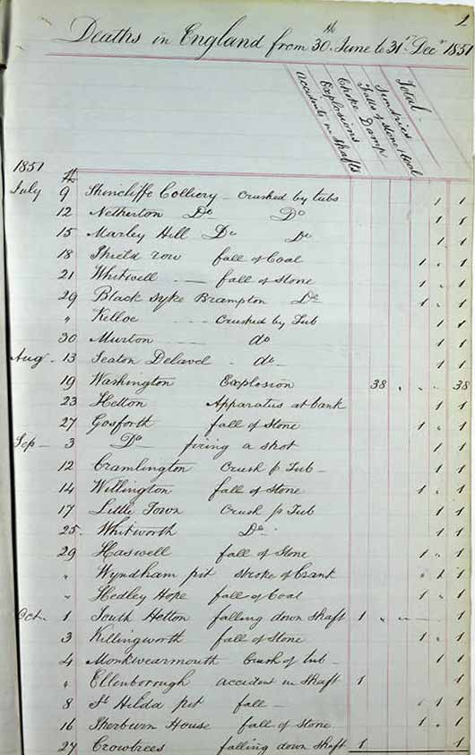

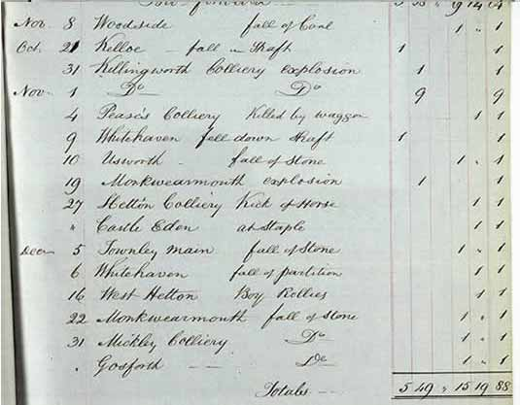

(PRO ref: HO 87/53)

