



4a What are the people wearing so that they can drag the tubs of coal? Describe how this could be uncomfortable or cause injury.
4b Many children died in the mines whilst doing this work. In what ways would this method of moving coal have been dangerous? How could fatal accidents have been caused using this method?
4c Many of these children worked from 6 in the morning to 8 in the evening with up to one and a half hours break. Work out how many hours of work this was. Compare it to your school day, or the hours you might do in a job.

These are prints of young persons included in Lord Ashley's report on children in mining from 1842. Although children under ten and all women and girls were banned from working underground as a result of the report, boys over ten continued to be used underground. The conditions shown in the drawings would still have existed during the time of the Great Exhibition. They show how young persons were used to move the coal to the surface.

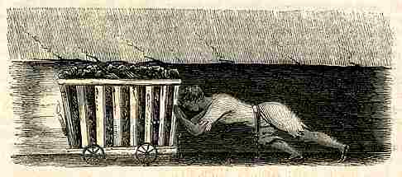

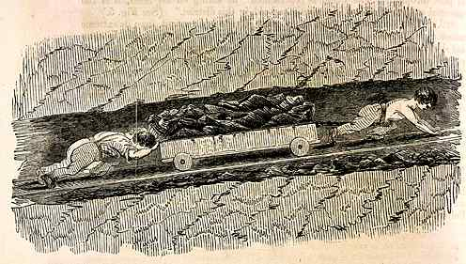

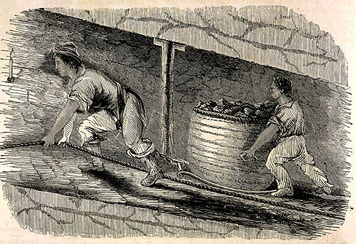
(PRO ref: ZHC 2/79)

These are witness excerpts from the report. They are interviews with young people working in the mines. Read them and think about how different children's lives were in the 19th century.

