



5a The inspector was also responsible for coalmines in areas of Scotland. Were the coalmines better in England or Scotland? How does he believe that the Scottish coalmines could be improved?
5b Read the second paragraph, what reasons does the inspector give for the air in coalmines being so poor?
5c Read paragraphs four and five, what does the inspector believe would be the quickest way of improving mine safety?
5d Why does he think this is not happening?

This is the conclusion of the inspector's report you have looked at in sources 1-3. Here he sums up his findings and makes recommendations.

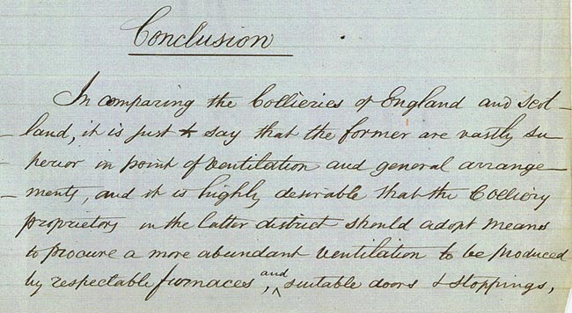

(PRO ref: HO 87/53)

