



1a. Look carefully at the source. Which crimes had been committed?
1b. How did publishing information such as this help:
i) The police?
ii) The general public?

This is a request for information to help solve crimes. It is from the Police Gazette dated 3rd February 1845. The Police Gazette was a weekly newspaper that the government produced giving details of crimes committed and information needed.

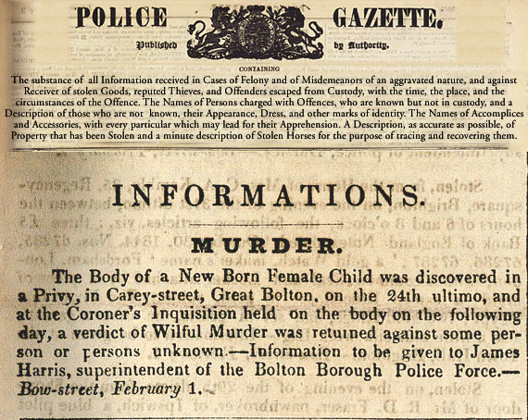

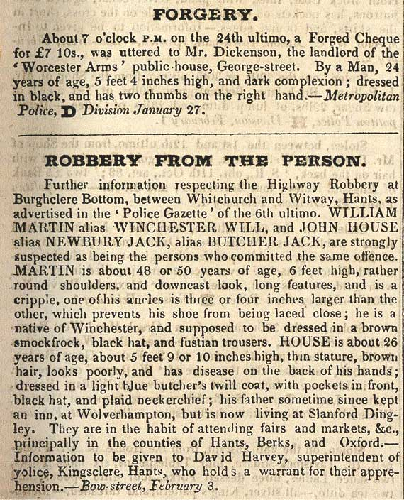

(PRO ref: HO 75/18)

