



2a. Read source 2 carefully. How many different ways of breaking into a house are described?
2b. Why was house-breaking a very common offence in Victorian Britain?
2c. Design a poster. What advice would you give a householder if you were telling them how to prevent criminals from breaking into their house? You could design a poster or leaflet about this.

A prison governor who asked some of the inmates in his prison, how they had committed their crimes wrote this. In this source an inmate describes how to break into a house.

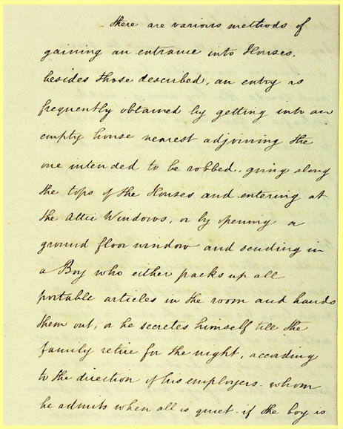

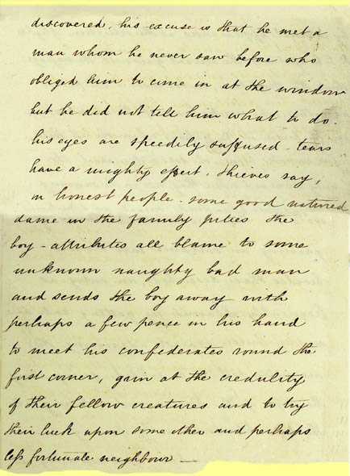

(PRO ref : HO 73/2)

