



3a. Why was it more difficult to break into a warehouse than a house?
3b. What evidence is there in sources 2 and 3 that burglaries in Victorian Britain were well planned?
3c. Use the information from source 2 and 3 to write your own entry for the Police Gazette (source 1 will give you some ideas) asking for information to help solve a burglary.

This was written by the same prison governor who wrote source 2. In this source an inmate describes how to break into a warehouse.
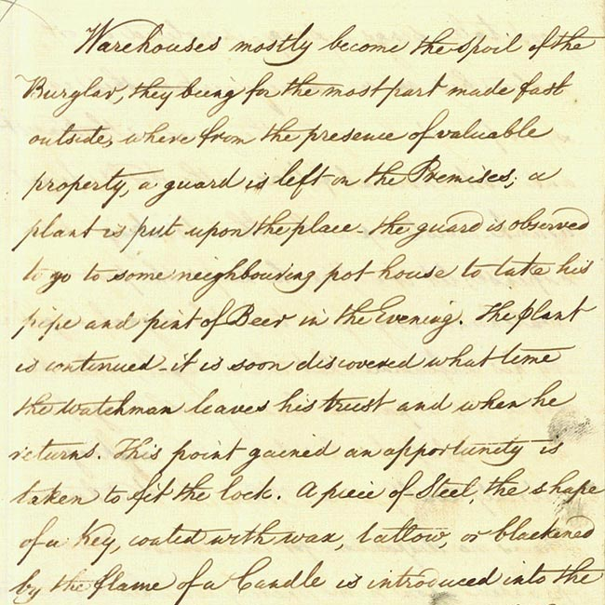

(PRO ref: HO 73/2)

