



4a Look carefully at the photographs and the details of each prisoner. What can you learn from these photographs about the prisoners in Oxford gaol? Think about who they were, their ages and crimes.
4b Which of their crimes is the most serious in your opinion and why?
4c Would similar sentences be given today for these crimes?

These photographs show four prisoners from Oxford Gaol. Their photographs were taken because the government was trying to prove a theory that criminals looked different from other people. They were hoping to use the photographs to reach conclusions about what criminals looked like so that they could then be easily spotted! [ D=Days, HL=Hard Labour, Stlg=Stealing]

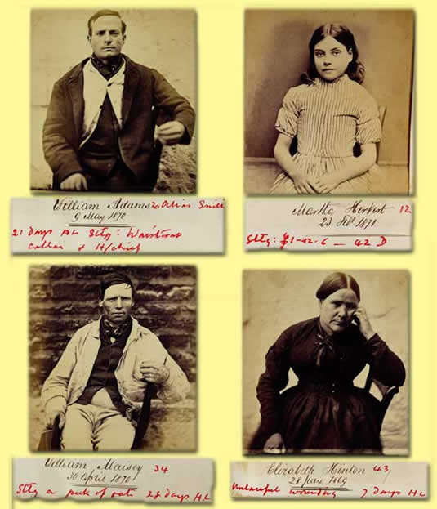

(PRO ref: PCOM 2/352)

