



5a. What can you learn about the prisoners kept onboard the Warrior from this list?
5b. What is the most common crime shown on the list?
5c. Do you think that all of the punishments are fair? Think about the seriousness of the crime committed and the length of sentence the prisoner received.
5d. Try to compare the different types of crimes to see if the punishments are consistent.

HMS Warrior was one of the convict hulk ships used to keep prisoners before they were transported. This source is an extract taken from a list that shows the prisoners that were aboard HMS Warrior in December 1849.

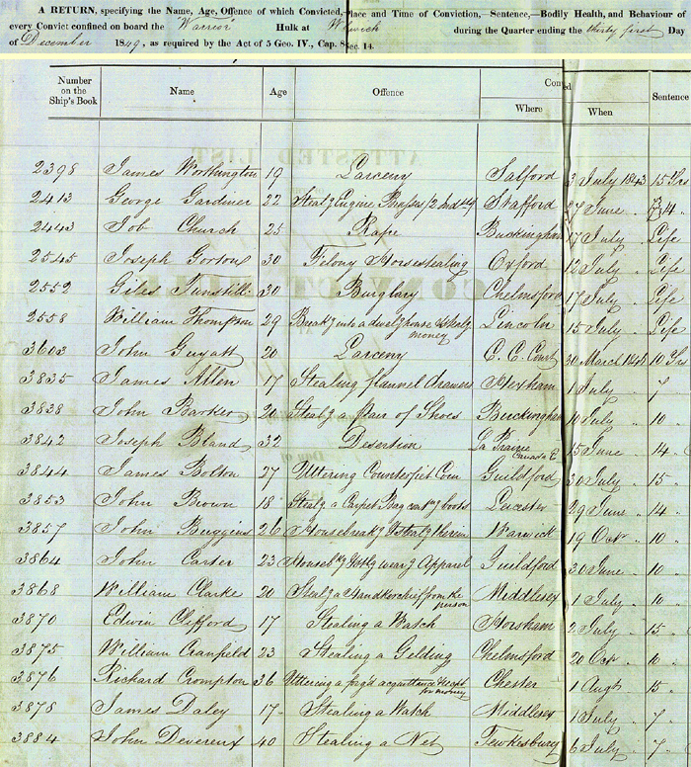

(PRO ref: HO 8/102)

