


Look carefully at source 6 and look back at source 5 to help you complete the tasks below
6a. Describe what you think conditions would a have been like on board HMS Warrior.
6b. Draw up a list of possible advantages and disadvantages of using hulks.

Look back at source 4 and 5

6c. What differences are there between the prisoners at Oxford gaol and those on HMS Warrior?

6d. Are there any similarities between the prisoners?

These three engravings were made in 1846 and show the convict hulk ship HMS Warrior.
(PRO ref: ZPER 34/8)

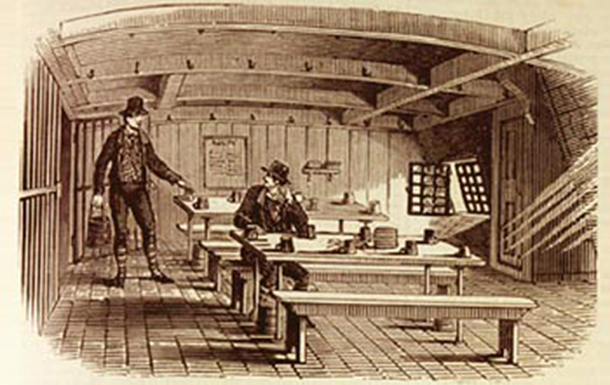

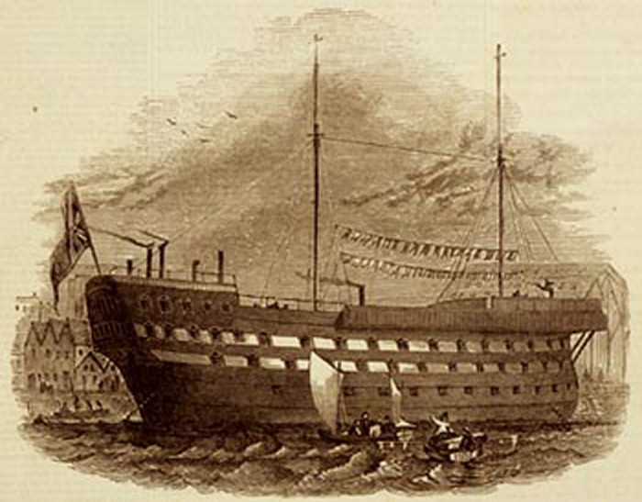

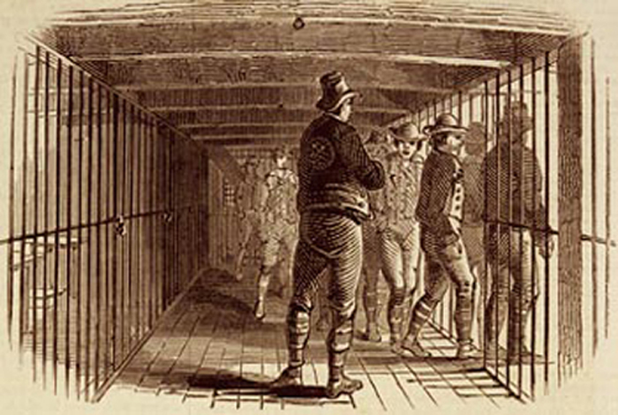
(PRO ref: ZPER 34/8)

