



7a. Describe how the treadmill worked.
7b. Why do you think that the treadmill was separated into different compartments?
7c. This form of punishment was de-moralising and exhausting. Why, therefore, do you think that prisoners were made to do it?

This picture shows prisoners working on a treadmill. Prisoners would be required to trudge up and down the steps for 6 hours a day.

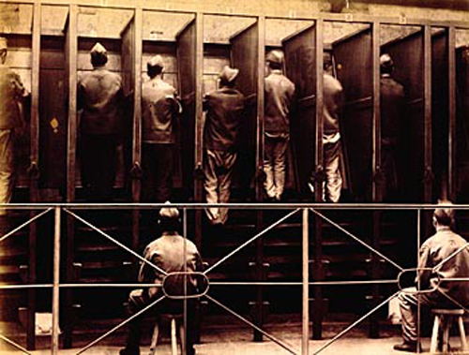

(PRO ref: COPY 1/420)

