Threat level table
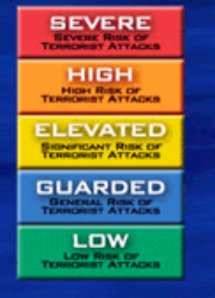
Study the sources and decide how worried you think the British government was at the time of each source. Record your views in the table below. You can use a colour code to indicate the extent of the threat (the US government uses this scale today).

Source | Brief summary | Suggests threat level was … | Comments
1 | Cartoon image – Hitler is confident he will invade but British soldier blows him away | Low | Could be propaganda to reassure British public – they did not know full story.
2
3
4
5
6
7
8

