Worksheet (a)
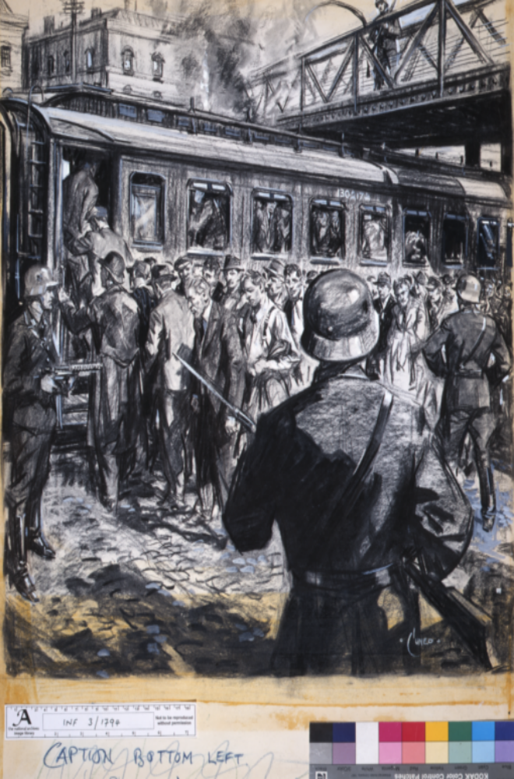
Lots of dark shadows are included in the drawing to make it…

The main message of the drawing is …

