Worksheet (b)
This guard is looking on to make sure that…

The main message of the drawing is …

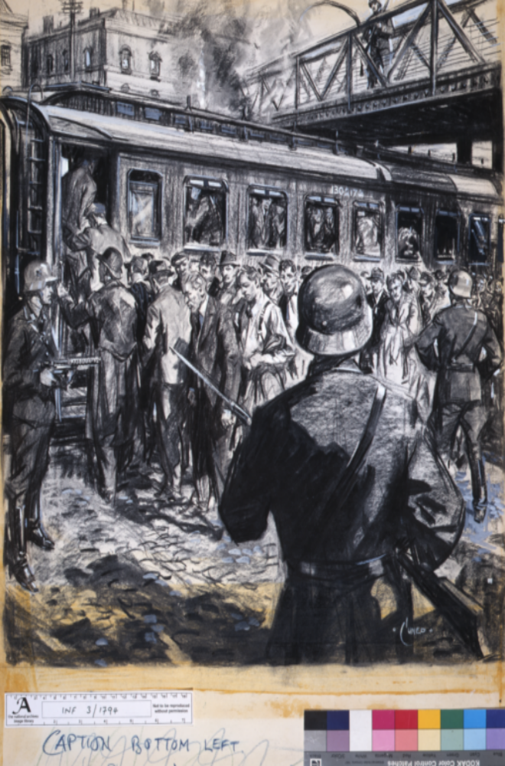
These men look like prisoners. This one looks as if…

Travelling by train suggests that these men will…

This guard has a machine gun pointed at the men that suggests…

This guard has a …

Large numbers suggest that conditions on train will…

Lots of dark shadows are included in the drawing to make it…

The caption is missing. It might have said: ‘Support the war effort, or this could be your family’. Can you think of a caption?

